**Camel Infectious Diseases under One Health Concept**

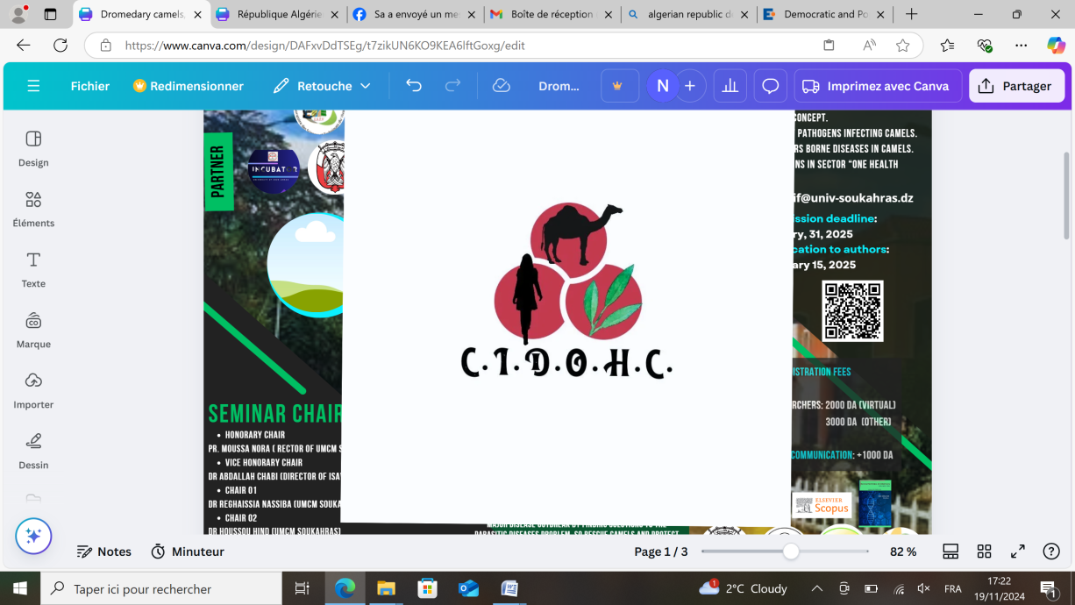**May.17-18.2025**

**Participation Form**

|  |  |
| --- | --- |
| **First Name** |  |
| **Last Name** |  |
| **Function** |  |
| **University/organization** |  |
| **E-mail** |  |
| **Intend to participat with** | **۝** Oral communication  **۝** Oral communication (online)  **۝** Poster communication |
| **Presence mode** | **۝** Online  **۝** By Person |
| **Topic** | **۝** Epidemiology of infectious diseases in camels under one health concept.  **۝** Zoonotic impact of pathogenes infecting camels.  **۝** Vectors and vectors borne diseases in camels.  **۝** Free communications |
| **The abstract will be published in the proceeding** | **۝ Agree**  **۝ Don’t agree** |
| **Abstract** | |
| **Title** | |
|  | |
| **Keywords** | |

## Important: The abstracts figure only in English in Revista Electronica de Veterinaria -ISSN: 1695-7504-