وزارة التعليم العالي والبحث العلمي

Ministry of Higher Education and Scientific Research
جامعـة محمد الشريف مساعدية  سوق أهراس | 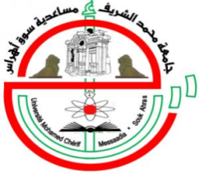 | Mohamed Cherif Messadia University Souk Ahras

Faculty of Nature and Life Sciences

Department of ………………

MASTER THESIS
Presented in fulfillment of the requirements for the Master’s Degree
Title

Field of Study

Title of the Field
Specialty

Title of the Specialty

Presented by
Student 1 Full Name and Student 2 Full Name
Members of the Thesis Committee

CHAIR COMMITTEE: Full Name |  | Degree | U.SOUK-AHRAS
SUPERVISOR: Full Name |  | Degree | U.SOUK-AHRAS
CO-SUPERVISOR: Full Name |  | Degree | U.SOUK-AHRAS
EXAMINER : Full Name |  | Degree | U.SOUK-AHRAS
Academic Year: 2024/2025

