Study of Wintering Strategy of Common Coot Fulica atra in Guerbes-Sanhadja Wetlands (Skikda, North-Eastern Algeria)
Amina Aouissi^{1, 2}, Sihem Sedddik¹, Wahiba Boudraa², Moussa Houhamdi^{2*}
¹Department of Biology, Faculty SNV, University Mohamed Cherif Messaadia, Souk Ahras (Algeria).
²Biology, Water and Environment Laboratory (LBEE). Faculty SNV-STU, University 8 May 1945 Guelma. Bp. 401 24000 Guelma (Algeria).
Abstract

The monitoring of common coot Fulica atra (Rallidae) ecology was done in Guerbes-Sanhadja wetlands. The results showed that this bird was abundant in these sites. In this study, it could be noted that at the level of these aquatic ecosystems, Common Coot due to its gregarious character have been concentrated in water far from the banks of the sites studied near the tufts of Typha angustifolia and Scirpus lacustris, and formed two distinct groups. The study of the diurnal activity rhythms throughout the wintering period has shown that feeding has dominated by far the total balance sheets, and this in all the wetlands which showed the role of daytime gaining ground of these bodies of water. This was observed in the water (by spout, immersion of the head in the water, by tilting of the front of the body in the water) and on the banks (grazing grass near the belts of water).

Keywords: Common Coot, Fulica Atra, Guerbes-Sanhadja, Wetland, Wintering, Breeding, Gregarious.

Corresponding author: Moussa Houhamdi
e-mail houhamdimoussa@yahoo.com
Received:16 December 2017
Accepted: 25 March 2018

- Introduction
For birds as for any species (animal and plant), the annual cycle is dictated by biological phases (wintering and breeding), linked by the migration periods of certain species (such as: Anatidae) (Toubal et al., 2014). The wintering period, is a pivotal phase of transition between two periods of reproduction (Tamisier and Dehorter, 1999), also the physiological state of the waterbirds during winter phase determines to a large extent the success of population reproduction and dynamics (Allouche et al, 1990). Algeria by its richness and diversity in wetlands (more than 254 wetlands), has taken a pivotal role in the migration systems in the West Palearctic (Houhamdi, 2002), and the three Maghreb countries (Algeria, Tunisia and Morocco) have been a large wintering area for many Eurasian-nesting species whose Mediterranean area is the main winter quarters (Isenmann and Moali, 2000). This wetland regularly attracts a large number of Anatidae and Coot species (Houhamdi, 2002, Bara et al., 2013), thanks to the good conditions that have been offered during wintering and nesting season (Ledant et al., 1981, Isenmann and Moali, 2000).
This bird is very abundant throughout the Western Palearctic and in the humid areas of north Africa (Isenmann and Moali, 2000, Ledan et al., 1981), and it is a breeding and sedentary species in Algeria (Rizi et al., 1999, Samraoui and Samraoui, 2007, Allouche et al., 1990). Its distribution in Algeria has been noted in the north area, including the highlands and the Sahara (Ledant et al., 1981, Isenmann and Moali, 2000, Samraoui and Samraoui, 2007, Samraoui et al., 2011).
In this study, the results of the wintering of this Rallidae in the main Guerbes-Sanhadja wetlands complex (north-east of Algeria, site of international importance) including: abundance, spatiotemporal occupation and balance of diurnal time budget were investigated. This was done in order to deduce the ecological role, and understand the functioning of these wetlands to this species of bird.
Site Description
The Guerbes-Sanhadja is an eco-complex wetland situated on the east of Skikda (36 ° 46'-37 ° 1 'N, 7 ° 8'-7 ° 25' E) (Fig 1), it is limited to the north-east by the Edough massif, to the northwest by the Filfila massif, to the southwest by the Boumaïza massif, and to the southeast to the near in Fetzara Lake, the area of ​​the wetland complex is 42,100 ha, and the wetland area itself is around 20,000 ha (Toubal et al. 2014). The hydrographic system consists of Oueds (El Kebir Oued) and Garaets. The complex is composed of Garaets, the largest ones are: Beni M'Hamed (380 ha) and Messaoussa (300 ha), and all the complex has been classified as Ramsar sites according to the criteria 2, 3, 6 and 8 since 2 February 2001 (Samraoui and De Belair 1997, Metallaoui 2010, Bara et al., 2013). The hydro-system of the Guerbes-Sanhadja region is a diversified area, many helophytes and endemic aquatic plants such as: Nymphaea alba, Typha angustifolia, Phragmites australis, Scirpus maritimus, Scirpus lacustris Iris pseudoacaurus and rare Pteridophyte Salvinia natans have been observed (Samraoui and De Belair, 1997, Metallaoui 2010, Bara et al., 2013).
According to the bibliography, the eco-complex has served as a nesting and wintering site for more than 79 species of waterfowl, belonging to 18 families, the most important belonging to the family of Anatidae; some of them have been cited in the Red List of IUCN, such as: White-headed duck Oxyura leucocephala, Ferruginous Duck Aythya nyroca and Purple swamphen Porphyrio porphyrio (Rallidae) (Samraoui and De Belaire, 1997, Metallaoui and Houhamdi, 2010, Metallaoui et al., 2009, Bara et al., 2013). Two anatidae have been observed in Garaet Hadj Tahar: tufted duck (Metallaoui and Houhamdi, 2008) and Red-crested Pochard Netta rufina (Metallaoui et al, 2009).

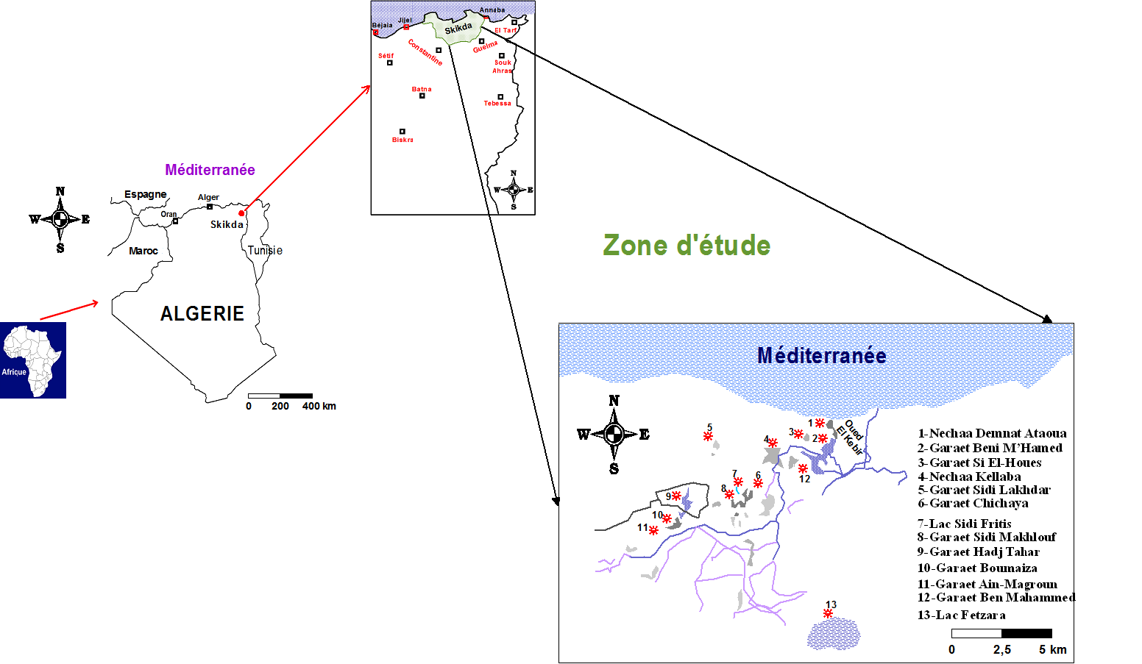
Figure 01. Location map of the study area.
- MATERIAL AND METHODS
In order to evaluate the number of common coot in Guerbes-Sanhadja wetlands, bi-monthly counts were done during three winter seasons (from September 2010 to April 2013), at the level of all water bodies. The total abundance of each site was counted individually if the bird population was close (less than 200 m), and had a small population (less than 200 individuals). It was estimated visually in case where groups of birds were distant and had high numbers (distance greater than 200m and more than 200 individuals) (Blondel, 1975). Also, the diurnal time budget of this bird was done to determine the role of surrender Garaets. Seven activities were noted: feeding, sleeping, swimming, plumage maintenance, flight, parry behavior and antagonism (Baldassare et al., 1988).
The food activity was subdivided into four different modes: feeding with the beak on the water, feeding by the immersion of the head in the water, feeding by tilting of the front of the body in the water, and feeding on foot in mudflats and banks (Altmann 1974). Regular observations of diurnal activity rhythms were followed by the Scan method (Altmann 1974) during the three years (2010-2013) in Garaet Hadj Tahar, Beni M’hemed, Messaoussa, Dahria and Haouas. Statistical analysis was carried out using an ANOVA test to analyze the inter-site and inter-season variations in the numbers of the coot-mash in the Guerbes Sanhadja eco-complex. Also, CPA (Principal Correspondence Analysis) was checked to understand the strategies of the spatio-temporal occupation of the coot in this eco-complex laying the three seasons of monitoring (2010-2013).
- RESULTS
Evaluation of Inter-site variation:
Figure 2 shows the common coot’s wintering from September and to March. On average, the number of coots in the wetlands of Guerbes-Sanhadja fluctuated between 1170 and 3210 individuals (Figure 2). The evolution of the populations generally showed a Gaussian pace (Figure 2). The minimum abundance was recorded during the beginning and end of the study period, between September and April. The highest numbers were recorded during November, and lasted until February explaining either the massive arrival of the populations, or the grouping for the prenuptial migration (Figure 2). During the three winter seasons, the abundance of the species varied from one site to another; the Kruskal-Wallis statistical test showed significant differences (H = 508.8466 p-value <0.0001). The highest concentrations of this species have been recorded in the Hadj Tahar Garaet (Figure 4).

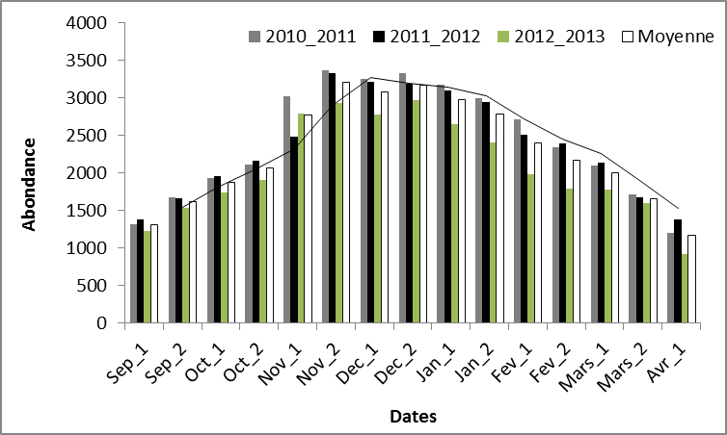
Figure 02. Evolution of common coot number in Guerbes-Sanhadja complex.
Evaluation of Inter-annual variation:
The study of the heterogeneity of the distribution of the numbers of the coots between the three study seasons between 2010 and 2013 has been represented in figure 3, which showed a maximum number of coots counted in the fourteen (14) study sites, noted 1900 individuals during the first season, while the last season (2012-2013) was marked by a slight decrease in the maximum strength of the coots (1700 individuals). This variation was weakly significant, and was confirmed by the Kruskal Wallis Test H (13, N = 630) = 508.8466 p = 0.0034).

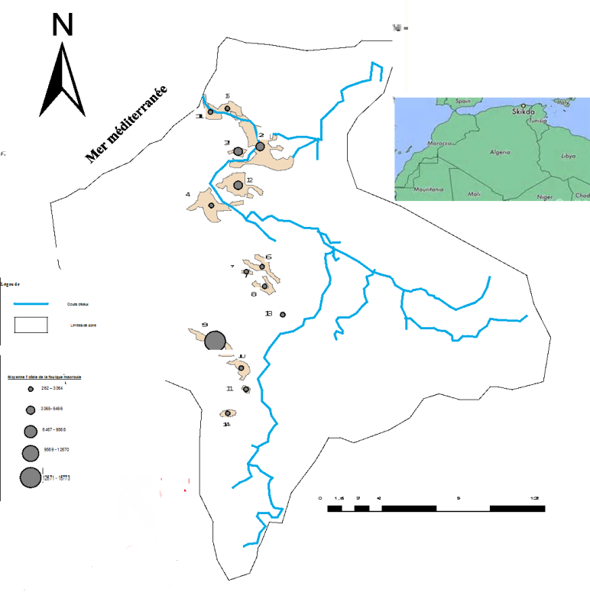
1: Garaet Hadj-Tahar; 2: Beni Mhemend; 3: Messaoussa; 4: Haouas; 5: Sidi Fritis; 6: Dahria; 7: Sidi Makhlouf; 8: Nechaa Khellaba, 9: Boumaiza; 10: Ain-Magroun; 11: Demnat Ataoua; 12: Chichaya; 13: El Guelb; 14: Ain Nechma
Figure 03. Mean values distribution of the common coot in Guerbes-Sanhadja wetlands.
The common coot population structure
In general, it was emerged that the wintering season was subdivided into three major periods (Fig. 4)
Start wintering (September and October, beginning of November): where the first winterers began to colonize these water bodies, with low numbers which did not exceed 2000 individuals.
Mid-winter (from November to February) where the following wintering populations’ total abundance increased, and reached to its maximum.
End wintering (March-April), when all wintering populations left these wetlands, and remained in these water bodies only breeding individuals.

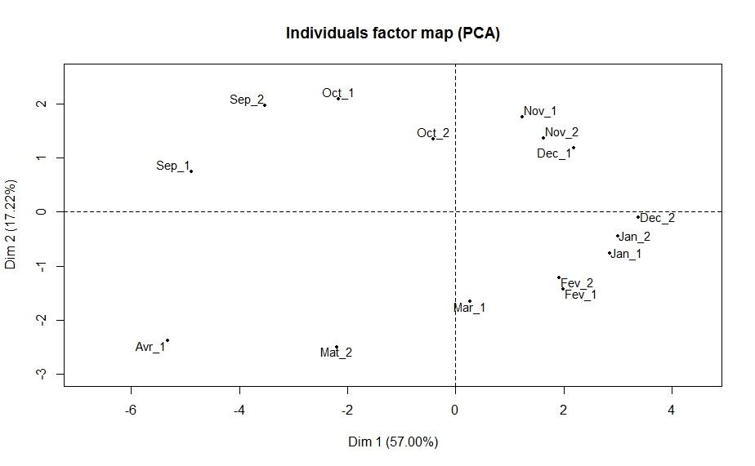
Figure 04. Factorial layout 1x2 of ACP about the temporal distribution of the common coot in Guerbes-Sanhadja complex.
Study of diurnal activities time budget
The assessment of the diurnal time budget of the common coot in five Guerbes-Sanhadja wetlands revealed that diet was the predominant activity with rates ranging between 60 and 65% (Figure 5). This activity was observed both on the banks and in the open water, showing the diurnal role of these wetlands. It was followed by the swimming activity with 23 to 30%. Grooming, flying, parrying and antagonistic behavior, represented secondary activities occupying the last ranks in the assessment of the behavior of this Rallidae in the five sites studied (Garaet Hadj Tahar, Garaet Beni-Mhamed, Garaet Messaoussa, Garaet Dahria and Garaet Haouas). The same observations have been reported in the Lake of Birds, North-East Algeria (Houhamdi, 2002), the Jijel wetland eco-complex (Mayache, 2002) and in the Setif wetland eco-complex (Baaziz et al., 2011).

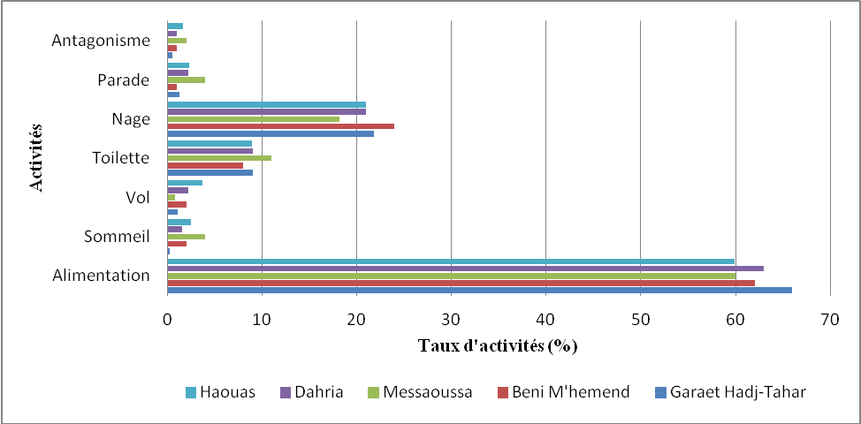
Figure 05. Diurnal time budget of the common coot in five wetlands of Guerbes-Sanhadja complex.
The results of the PCR (presented in the 1x2 factorial plane of the PCR) collecting 76.19% of the total variation of the information, or the axis 1 of the ACP represented only 42, 01% of the information, and separated the activities of comforts to the activities of winnings. While axis 2 separated dirty environments from freshwater sites. It was noted that the feeding activity, parade and antagonistic activity were activities dominated in the Hadj Taher and Dahria Gareat sites which are freshwater environments and a moderately large area compared to the Messoussa sites, Beni M'hemed and Houass which displayed the dominance of comfort activities such as swimming, flying and toilet activity. During the wintering period, the coots fed on moderately wide, deep and soft sites that favored enough food (phytoplankton, macrophytes and insects, etc.) which made them an excellent feeding place.

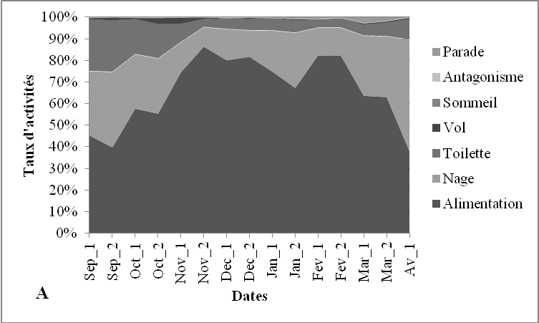
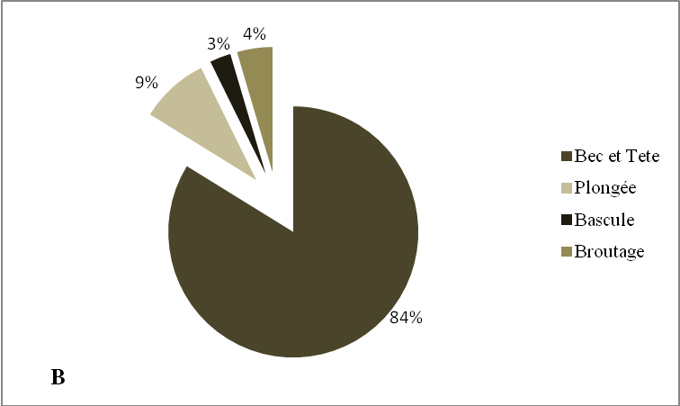
Figure 06. (A) Bimanual evolution of diurnal time budget, (B) Total rate of diurnal time budget of the common coot in Guebes-Sanhadja complex.
- DISCUSSION
The assessment of the diurnal activity patterns of the winter period of the Coot in the Garaet Hadj Tahar, of the Guerbes-Sanhadja complex between 2010 and 2013, which included 294 hours of observations and monitoring, revealed that the activity of feeding was the major diurnal activity of the common coot that is a herbivorous bird that feeds mainly during the day, and spends most of the night resting (Mc Knight and Hepp, 1998). During the study period, this activity was marked with regular rates that generally fluctuated between 32.88 and 86.21%, ie 2h30 mn and 6h. According to the results, the coot preferred to feed in the water rather than in the banks, where it looked for food by immersing its beak or its head (Fig. 6). Metna (2010), reported that the rate of tilting feeding took a low part due to the long time that the coot has been in the water. Swimming, in the coot, was a basic and more expensive behavior (Wooley and Owen, 1978 in Allouche, 1988). It occupied the second rank with higher or lower rates in September and March, respectively; the maximum was then recorded in April (55.92%, 3h91mn). Followed by the grooming behavior with a rate of 9%, the highest values ​​were recorded at the beginning of wintering (24%, ie 1h74 min). This activity has been observed both on the banks and in the water, with a higher rate on the banks. Sleeping activity, observed in November and December, characterized a comfort behavior of these birds (Zitouni et al., 2013). The flight, the courtship and the behavior of the antagonism occupied only reduced rates in the balance of the activity rhythms of the wintering coot. Generally, this Rallidae preferred to swim than to fly (Allouche, 1987), so the flight occurred due to a disturbance. The pair formation of the coot increased early January then decreased, and the numbers of peaks were noted in March (2.72%). Antagonist activity was noted with very low levels throughout this study, and reached to its maximum (0.46%) during the first decade of December.
- CONCLUSION
During this study, the common coot Fulica atra was very abundant in the five wetlands of Guerbes-Sanhadja. They were frequent in different ecosystems of fresh or dirty waters. Two ecological populations were distinguished: a sedentary and a more consistent breeder that used the aquatic ecosystems only during the winter period. The present study revealed that coots used large areas, wet areas, and the medium and shallow freshwater wetlands, but only Garaet Hadj Tahar was the preferred site for the wintering coots. The study of the diurnal time budget, showed that the total balances in the five sites were dominated by an increased diet, thus conferring the role of diurnal gaining ground for this species. This activity was observed in the water (by spout, immersion of the head in the water, by tilting of the front of the body in the water), and on the banks (grazing of the grass near the belts of vegetation dominated by Juncus acutuset and J. maritimus). At the level of these aquatic ecosystems, the common coot due to their gregarious character have been concentrated in water far from the banks (near the tufts of Typha angustifolia and Scirpu slacustris), and formed distinct groups. In this study, a management plan was proposed for the conservation and restoration of these wetlands.
- ACKNOWLEDGMENT
The authors would like to thank all those who participated in the collection of these data and the companions of exit including: Dr. Guergueb Elyamine (Doctor of Biology at the University of Ghardaia), Mr. Guezgouz N / Eddine (Assistant Professor at the University of Souk Ahras), and Dr. Allalgua Amel (University of Souk-Ahras), Dr. Amorabda Wahiba, Dr. Halassi Ismahan, Dr. Merzoug Seyeddine and Dr. Bouchaala Laid. The thanks would also go to the residents of Garaet Hadj Tahar, mainly the families Fellah, Snani, Litim, Ksentini for their receptions and hospitality.
REFERENCES
- Allouche L (1987) Consideration of food activity in Chipeau Ducks and wintering wintering Coots in the Camargue (in French). Alauda, Vol 55 (1), 316-320.
- Allouche L (1988) Compared wintering strategies of the Chipeau duck and the Coot macroule for a spatiotemporal sharing of the Camargue wetlands (in French). Doctoral thesis. Univ. Sciences and Techniques of Languedoc, Montpellier. 179p.
- Allouche L, Dervieux A, Tamisier A (1990) Distribution and nocturnal habitat compared Chipeaux and Foulques in the Camargue (in French). Earth & Life, Vol 45 (2), 165-176.
- Altmann J., 1974. Observational study of behaviour: sampling methods. Behaviour, 4 (2), 227-267.
- Baaziz N, Mayache B, Saheb M, Benssaci T, Ounissi M, Metallaoui M, Houhamdi M (2011) Phenological status and reproduction of bird stands in the Setif wetland ecosystem (Highland, East of France) 'Algeria) (in French). Bull. Inst; Scien; Rabat.sect. Scien. 33 (2), 77-87.
- Baldassare G.A, Paulus S.L, Tamisier A, Titman R.D (1988) Workshop summary: Techniques for timing activity of wintering waterfowl. Waterfowl in winter. Univ.Minnesota press, Minneapolis. 23p.
- Bara M, Merzoug S, Bouslama Z, Houhamdi M (2013) Biodiversity and Phenology of Rallidae and Anatidae in Garaet Hadj-Tahar (North-east of Algeria). Annals of Biological Research 4 (6): 249–253.
- Blondel J (1975) Analysis of waterbird stands. Element of an ecological diagnosis. I: The progressive frequency sampling method (E.F.P.) (in French). Earth Life Ecology Review 29: 533-589.
- Houhamdi M (2002) Ecology of avian populations of Lake Birds (in French). State PhD Thesis in Ecology and Environment, Univ. Badji Mokhtar from Annaba. 175p.
- Isenmann P, Moali A (2000) Birds of Algeria (in French). Society of Ornithological Studies of France, Paris. 283p.
- Ledant J.P, Jacobs J-P, Jacobs P, Mahler F, Ochando B, Roché J (1981) Update of the Algerian avifauna (in French). Gerflaut, 71 (1), 295-398.
- Mayache B (2002) Inventory and ecological study of aquatic birds in the Jijel wetland eco-complex (Algeria) (in French). Doctoral thesis. Univ. Badji Mokhtar. Annaba.110p.
- Mc Knight S. K, Hepp G.R (1998) Foraging niche dynamics of Gadwalls and American coot in winter (in French). The Auk, 115 (1), 670-683.
- Metallaoui S (2010) Ecology of the aquatic avifauna of Garaet Hadj-Tahar (Western Numidia) (in French) [Ph.D. Badji Mokhtar University, Annaba.
- Metallaoui S, Atoussi S, Merzoug A, Houhamdi M (2009) Overwintering of the White-headed Duck (Oxyura leucocephala) in Garaet Hadj-Tahar (Skikda, North-East Algeria) (in French). Aves 46 (3): 136-140.
- Metallaoui S, Houhamdi M (2008) Preliminary data on aquatic birds of Hadj-Tahar Garaet (Skikda, North-East Algeria) (in French). Afri. BirdClub Bull., 15, 71-76.
- Metallaoui S, Houhamdi M (2010) Biodiversity and ecology of wintering waterfowl in Garaet Hadj-Tahar (Skikda, northeastern Algeria) (in French). Hydroécol. Appl., 17, 1-16.
- Metallawi S, Dziri H, Bourennene M, Benguiba M (2013) Ornithological values of wetlands in the Guerbes-Sanhadja eco-complex (Skikda, North-East Algeria) (in French). Bulletin of the Mediterranean water birds; Vol (1).9-17.
- Metna F (2010) Trophic ecology, ethology and reproductive biology of the coot Fulica atra (Linnaeus, 1758) in the Reghaia Lake (Algiers) nature reserve and in the Djebla dam (Kabylia) (in French). Doctoral thesis. Univ. Mouloud Mammeri. Tizi Ouzou. 177p.
- Rizi H, Benyacoub S, Chabi Y, Banbura J (1999) Nesting and reproductive characteristics of coots Fulica atra breeding on two lakes in Algeria. Ardeola, 46 (2), 179-186.
- Samraoui B, De Belair G (1997) The Guerbes-Sanhadja wetlands: Part I, Overview. Ecologie. 28: 233-250.
- Samraoui F, Al-Farhan A-H, Al-Rasheid K.A.S, Samraoui B (2011) An appraisal of the status and distribution of waterbirds of Algeria: indicators of global changes? Ardeola, 58 (1), 137-163.
- Samraoui F, Samraoui B (2007) The Reproductive Ecology of the Common Coot Fulica atra in the Hauts Plateaux, Northeast Algeria. Waterbirds, 30 (1), 133-139.
- Tamisier A, Dehorter O (1999) Camargue: Duck and Fulk. Operation of a prestigious winter district (in French). Ornithological Center of Gard. Nimes. 369P.
- Toubal O, Boussehaba A, Toubal A, Samraoui B (2014) Mediterranean biodiversity and global changes: case of the Guerbès-Senhadja wetland complex (Algeria) (in French). Physio-gio; 8: 273-295.
- Zitouni A, Tahar A, Bouslama Z, Houhamdi M (2013) First data on the population structure and ecology of the coot Fulica atra (Rallidae) in the wetlands of the El-Kala region (North-East from Algeria) (in French). Rev. Sci. Technol., Synthesis 28: 25-33.

