**PEOPLE'S DEMOCRATIC REPUBLIC OF ALGERIA**

**MINISTRY OF HIGHER EDUCATION AND SCIENTIFIC RESEARCH**

**MOHAMED-CHERIF MESSAADIA UNIVERSITY**

**FACULTY OF LETTERS AND FOREIGN LANGUAGES**

**DEPARTMENT OF FOREIGN LANGUAGES**

LECTURE HANDOUT

IN

TECHNIQUES OF UNIVERSITY WORK

**First Year**

**(English LMD)**

**By: Dr. NACEREDDINE BENABDALLAH**

**ACADEMIC YEAR: 2018-2019**

**Preface**

The present lecture handout is destined to Algerian 1st year EFL students. Generally speaking, it is related to the field of research methodology but it is more concerned with the most important and appropriate techniques, strategies and procedures that are to a great extent needed by any university student seeking for success. These techniques will help them take responsibility for their own learning processes; enhance their own confidence, motivation, and self-esteem. These techniques will undoubtedly prepare them to become more well-adjusted adults, trustful, productive, and sane Algerian citizens.

This handout consists of two parts. The first part deals with five main chapters or courses to be handled in the course of the Semester One. The first course is a general overview on the subject *Techniques of University Work* (TUW) whereby the teacher introduces not only the whole syllabus, the objectives, the various teaching and learning procedures and activities/tasks, but the students’ performance assessment as well. The second chapter entitled *‘getting organized’*, examines the foundations and merits of good time management, its strategies and skills, the importance of scheduling, and the disastrous drawbacks of procrastination and stress and how to overcome both of them. *‘Getting informed’* is the third course. It identifies the dichotomy between library documentation and online (internet) documentation as well as their advantages and limitations. Chapter four is concerned with reading skills and strategies, and the difference between passive, active, and interactive reading. The last course deals with note taking techniques and systems among which the Cornell Method, the Outlining Method, the Mapping Method, the Charting Method, and the Sentence Method.

The second part to be conducted during Semester Two is comprised of four chapters. Chapter six describes various techniques of efficacious study namely memory and memorization, the contrast between concentration and distraction, and the benefits of both individual work and group work. If chapter four during semester one tackles reading skills and strategies, chapter seven aims at depicting writing skills and strategies focusing on text layout and content. Chapter eight is about ‘University Research Process’ (URP) through which 1st year EFL students will learn the steps of conducting a research work starting with choosing a manageable topic, changing it into a research question, identifying information sources, information gathering, evaluation and selection, and finally written and oral presentation. The last chapter takes account of effective exam preparation that requires adequate management of time, space, students’ motivation, and revision. It is worthy to note that chapter nine could be dealt with even at the end of semester one giving the students the opportunity to prepare and revise in an efficient and effective way.

**Contents**

**Semester One**

1. Techniques of University Work: General Overview
2. Getting organized
   1. Time Management
      1. How good is your time management?
      2. Time management techniques
      3. The importance of scheduling
      4. Overcoming procrastination
      5. Overcoming stress
3. Getting informed
   1. Library documentation
   2. Online documentation
4. Reading skills and strategies
   1. What makes a text difficult?
   2. Active vs passive reading
   3. Interactive reading
5. Techniques of note taking
   1. Cornell Method
   2. Outlining method
   3. Mapping method
   4. Charting method

**Semester Two**

1. Efficacious study
   1. Improving memorization
   2. Concentration vs distraction
   3. Individual vs group work
2. University work process
   1. Choosing a topic
   2. Identifying information sources
   3. Information gathering and selection
   4. Written presentation
   5. Oral presentation
3. Effective exam preparation
   1. Managing time
   2. Managing space
   3. Managing motivation
   4. Managing the unknown
   5. Managing revision

**Techniques of University Work**

**General Overview**

**Introduction**

It is nowadays widely recognized that teachers, educationalists, and academicians all over the world have subscribed to the belief that the major and ultimate goal of education is imparting essential knowledge and skills necessary for producing learners who will be able to solve real world problems that await them after school. In other words, education aims at shaping students’ character, and ensures their successful transition into a responsible adulthood. These future normal and well-adjusted adults will be more inclined to take risks, serve and care about their community. They will be identified with the virtues of discipline, self-control, respect, and thoughtfulness. In all, education is not, as John Dewey stated, preparation for life; education is life itself. It may sound idealistic but still realistic and achievable. The role of schools and universities is to prepare young and adult learners to be creative, cooperative, well-balanced and armed with a firmly-rooted sense of citizenship and public-spiritedness.

**Higher Education in a Changing World**

It is well-known that because of the global shift, education has become a process that takes place not only in a formal instructional institution but throughout all areas of learners’ daily life. When referred to as an institution, education relies upon a set of well-established norms and rules that direct and regulate each student’s social life. And consequently, enabling them to adopt and adapt the appropriate plans, procedures, and strategies in order to attain their goals. Their learning is based on required knowledge and skills that reinforce the way they behave appropriately in their dealings with others. In fact, what education tries to accomplish when intervening in a student’s life is to change them into good people living in a good society.

Throughout the world, over the last 150 years, many debates were dominated by the idea that the main aims of education have to be moral guidance, maintaining social order, and advocating the idea of the nation. Students who live in different communities and who share the same beliefs and values with their neighbours and with whom they daily interact, find themselves shifted into new educational settings (universities) and among strangers who do not share the same beliefs and values. However, they have to do their best in order to render social life possible within these settings. Emile Durkheim, one of the founding fathers of modern sociology, referred to it as social integration that can be realized when rules that are necessary for orderly social life are strictly enforced. Moreover, the French sociologist contended that education should the idea of the nation through which students could develop a sense of collective belonging and that they have a stake in society and that their efforts are valued. In fact, Durkheim’s views still have a contemporary resonance because students need discipline and necessary skills as well as to take pride in the nation.

By the same token, Algerian higher education institutions aim at producing a particular type of student who is modeled in accordance with the qualities of character that are considered desirable of a normal adult. It is obvious that the idea of normal well-adjusted adult changes from one place to another due to different political, social, and cultural realities. Nevertheless, there is a tendency among scholars and reformers to consider three major goals of any contemporary public instructional institution:

1. Providing adequate skills like creativity, communication and collaboration and deep knowledge in order to prepare students, the future adults, to get a job and pursue a career in a highly competitive society. The future adults will, henceforth, contribute to the economic growth of the nation they belong to.
2. Preparing and inspiring students to participate in the civic life and become fully vital and trusted members of society. The chosen curricula must be based upon instilling in students the qualities of character of committed good citizens who are ready to take part constructively and democratically in the civic affairs.
3. Transforming and enriching the student’s life through the transmission of values, ideals, and ideas. As consequence, students will develop and reflect upon their character, talents, and attitudes in order to become good persons.

**Taking Stock of the Situation**

I have been teaching for more than thirty (30) years in high school first, then in university. I have always encountered a serious problem exemplified in the fact that a great number of students lack necessary techniques and skills to build up and maintain their learning. That is, I believe, commonplace with a great number of teachers in many schools and universities. They would argue that learners are unaware and unable to take control of their own learning. Indeed, the idea of meta-learning relies upon the students' perceptions, beliefs, and reflections on their learning. When students have a low level of meta-learning, they will find it more difficult and more demanding to adapt themselves successfully. Instead, education is restricted to filling the pail and testing. Learners are prepared only to pass from primary, to middle, then secondary school. Even in higher education, there is a clear-cut divide between what is actually taught and learnt through memorization and the main educational goal which is the successful transition into adulthood.

**The 4 Rs and Algerian Students**

The model of a normal and well-adjusted student is one of the main widespread goals of 21st century educational institutions. Algerian universities and schools must not make the exception. They are concerned with developing the appropriate qualities of the Algerian student character taking into account their inherent socio-cultural specificities. Nevertheless, four important qualities have proven to be essential to produce such model of students. (Figure 1)

Figure 1: Model of normal adult

1. Respect refers to the fact that students have to show the feeling that everything around them is worthy and deserves serious attention. They give respect to space, and time, as well as others’ age, race, religion, beliefs, and values. With mutual respect, they will become sane and well-rounded individuals and even leaders. With such element of character students will build relationships based on trust, and get rid of conflicts. Listening to others’ opinions is respect. Being honest and valuing knowledge is respect. Exercising proper conduct and taking responsibility for one’s own actions is respect.
2. The second trait of a normal adult character is responsibility. Students become responsible when they suit the action to the word; when they account for their behaviour; when others trust them; when they take care of themselves and their learning. A responsible student is the one who strives to be always consistent i.e. continues steadily in the same way without any change in behaviour and attitudes. A responsible student neither complains and blames the world nor gets rid of one’s guilt in case of failure.
3. Relationship, the third quality, is also essential in a student’s life. Good teacher-student and student-student relationships would likely favor an environment where they feel safe and valued. Good relationships render the learnt knowledge and skills less authoritative and fixed. It is through dialogues that concepts become alive and can be either challenged or agreed upon. Hence, students’ understanding and knowledge will grow leading to more beneficial cooperation. In fact, without relationships, the so-called normal well-adjusted adult is bound to feel empty and useless.
4. The last trait is rigour. It is the quality of being strict, severe, and careful. In education, a rigorous student is the one who is constantly challenging and asking questions about the accuracy and truth of what is being learnt. With rigour, students will learn how to value effort, perseverance, hard work, and persistence. They will, very likely, not give up or feel affected and overwhelmed when facing challenges.

These four traits will definitely produce a confident, valuable, normal, and well-adjusted Algerian citizen if they are thoughtfully integrated in well-elaborated and reflected curricula.

**Algerian EFL Students and University Life**

How is university different from high school?

|  |  |
| --- | --- |
| **Academic experience** | The aim is to obtain the best possible degree. Students are encouraged to discover new things, develop a critical mind, question what is being taught and form new ideas. The university helps them improve the way they study through a wide range of resources. They have to familiarize themselves with rules and regulations |
| **Social experience** | This includes everything else outside of studying: broadcasting, drama, sport, music, volunteering, photography…etc |
| **Residential experience** | The place where a student lives will shape their student experience. By this, we mean life in university halls of residence as well as commuting |
| **Life experience** | Going to University is a life changing experience.  The environment necessarily forces the development of the student, their mind, their thoughts, their opinions, who they are.  For some people it may be the first time they live independently.  Whether or not this is their first time, students have to juggle aspects of life such as money, accommodation, health, relationships, family and future career plans. |

**Algerian EFL Students and Technics of University Work**

Technics of University Work (TUW) is a subject that is dedicated to Algerian EFL students for two successive years. The suggested syllabi deal with a set of procedures and strategies that would help students take control and develop their learning on the basis of the above traits: respect, responsibility, relationship and rigour.

This subject should be presented as a *vital study kit* for each student through which a number of topics, issues, and techniques that favor their learning as well as prepare them for their future life as a responsible, rigorous, well-adjusted adult.

Learners will be presented with:

1. The merits of **time management** which is viewed as a set of principles, practices, skills, tools and systems that help them use their time to accomplish what they want. Effective time management favors punctuality, courtesy, efficiency, self-discipline, and control. Students will learn not only how to schedule and prioritize their activities, but overcome procrastination and stress as well.
2. The importance of **efficacious study** and use of the adequate techniques of memory, memorization, and concentration.
3. The harmful effects of all kinds of **distractions** that hamper and very often exacerbate learning.
4. The benefits of both **individual and group work**.
5. Appropriate tools for an **effective test/exam preparation** including the way time, space, motivation, and the unknown are managed.
6. The various ways of **getting informed** and reflecting upon sources of information, along with their limits.
7. The importance of the **reading skill** and the difference between passive, active, and interactive reading.
8. The usefulness of the different techniques and methods of **note taking** that could help students improve their knowledge and the act of memorizing.
9. The merits of the **university work process** that begins with choosing a topic and ends with a written and/or oral presentation. Such process will contribute to the notion of the future mature adult’s lifelong learning.

**Technics of University Work: Summary Statement**

1. **Suggested Syllabus**

|  |
| --- |
| **Group: 1st Year LMD (English)**  **Teacher: Dr. Nacereddine BENABDALLAH**  **Academic Year: 2018-2019** |
| **Semester One** |
| 1. Techniques of University Work: General Overview 2. Getting organized    1. Time Management       1. How good is your time management?       2. Time management techniques       3. The importance of scheduling       4. Overcoming procrastination       5. Overcoming stress 3. Getting informed    1. Library documentation    2. Online documentation 4. Reading skills and strategies    1. What makes a text difficult?    2. Active vs passive reading    3. Interactive reading 5. Techniques of note taking    1. Cornell Method    2. Outlining method    3. Mapping method    4. Charting method |
| **Semester Two** |
| 1. Efficacious study    1. Improving memorization    2. Concentration vs distraction    3. Individual vs group work 2. University work process    1. Choosing a topic    2. Identifying information sources    3. Information gathering and selection    4. Written presentation    5. Oral presentation 3. Effective exam preparation    1. Managing time    2. Managing space    3. Managing motivation    4. Managing the unknown    5. Managing revision |

1. **Sessions:**

Fourteen (14) sessions spread out over one semester equivalent to forty two (42) hours along with 2 sessions (3 hours) per week. Students’ assiduity is compulsory. Any absence has to be proved and three or more non-proved absences lead to the student’s exclusion.

1. **Objectives:**

-Acquiring and transmitting knowledge.

-Acquiring essential methods/tools/techniques to succeed.

-Emphasizing the role of research, reading, library work, etc.

**4.** **Evaluation:**

-Students are informed that there is **no semestral exam.**

-Promoting the use of some kind of **performance evaluation.** A system of portfolios of students’ work, reports, group works will help assess their progress, efforts, and achievements over time.

-Frequent quizzes and tests.

-Students’ oral and written presentations.

**5.** **Hot link:**

Students are informed that a weblog: [www.linguistics41.blog4ever.com](http://www.linguistics41.blog4ever.com) that has been made at their disposal by the teacher in order to download courses, activities ,as well as share their reflections, comments, hyperlinks, videos, and photographs in relation to techniques of university work. The blog is free access however if students subscribe to the blog, they will automatically receive notifications on the email addresses whenever the teacher uploads a new course or activity.

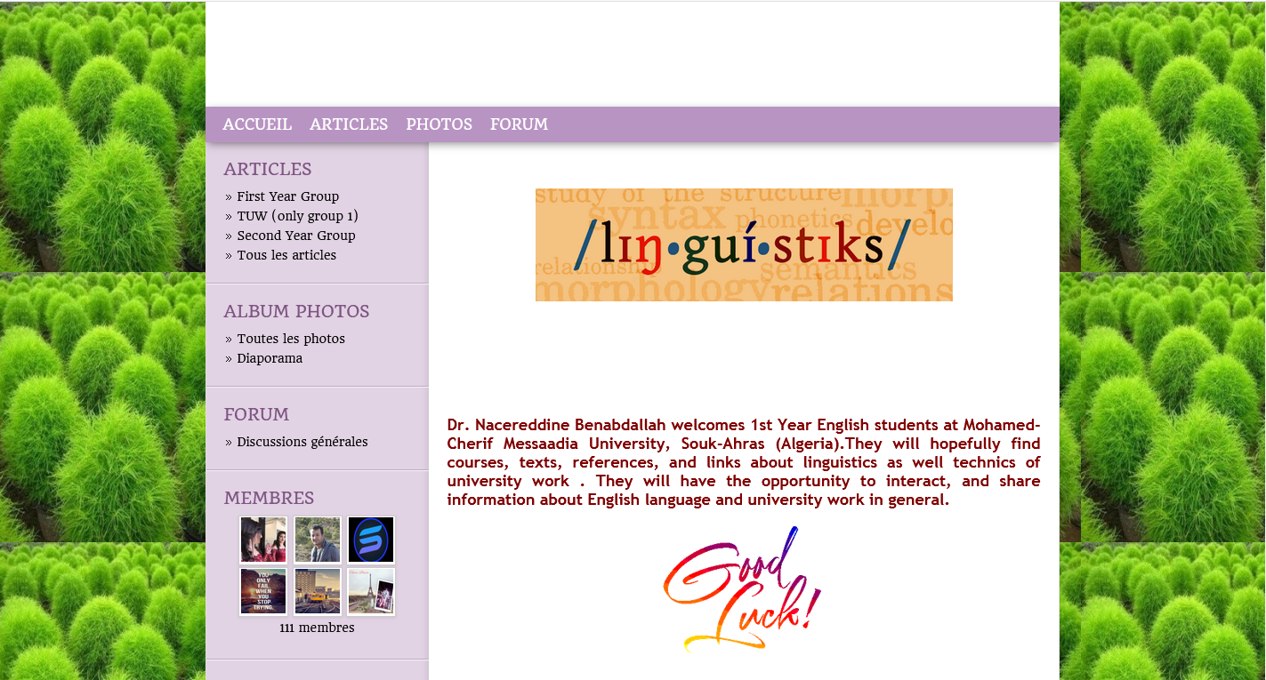

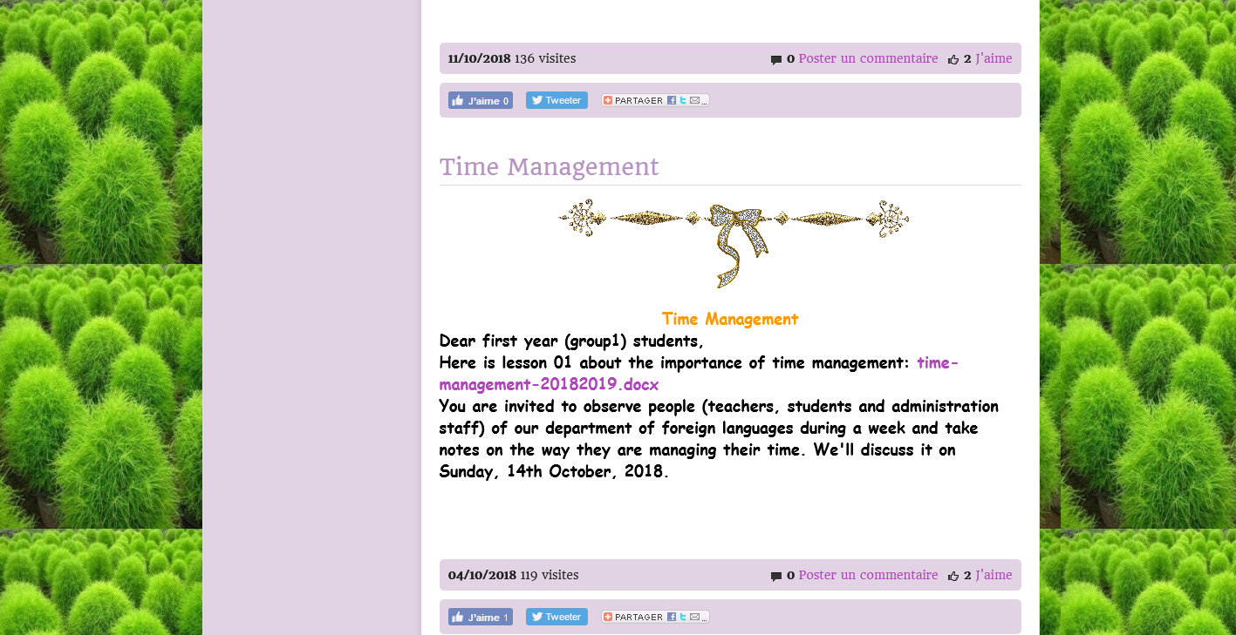

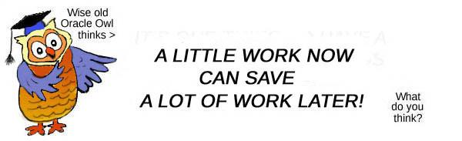**Getting Organized**

**Course 01:** **The Importance of Time Management**

**A/ Some Useful Expressions about time**

|  |  |
| --- | --- |
| 1. To have ***time*** on one’s hands. | 1. To spend the better part of one’s ***time*** doing something. |
| 1. Since the dawn of ***time***. | 1. All in good ***time!*** |
| 1. Doesn’t ***time*** fly! | 1. My ***time*** is / is not my own. |
| 1. ***Time*** heals all wounds. | 1. To have plenty of ***time*** to do something. |
| 1. Only ***time*** will tell. | 1. In the shortest possible ***time***. |
| 1. ***Time*** will prove me right. | 1. This old watch still keeps good ***time***. |
| 1. It’s a race against ***time.*** | 1. I wouldn’t give him the ***time*** of day. |
| 1. ***Time*** is on our side. | 1. Is the bus running to ***time***? |
| 1. ***Time*** is money. | 1. We got to the airport with ***time*** to spare. |
| 1. ***Time*** and tide wait for no man. | 1. I worked for her at one ***time***. |
| 1. There is no ***time*** to lose |  |
| 1. To make up for lost ***time.*** | 1. We’ll talk about that when the ***time*** comes. |
| 1. To make good / poor ***time*** doing something. | 1. It’s about ***time*** we taught her a lesson / isn’t it about ***time*** we got a new car? |
| 1. To pass the ***time*** doing something | 1. There’s no ***time*** like the present (let’s do it now) |
| 1. Take your ***time*** over it. | 1. We’ll have to decide some ***time*** or other. |
| 1. You took your ***time*** about it! | 1. I had the ***time*** of my life. |
| 1. To work part / full ***time*** | 1. In / on your own ***time.*** |
| 1. In ***times*** past / in former ***times.*** | 1. In times to come. |
| 1. ***Time*** was when doctors made house calls. | 1. To be ahead / before one’s ***time***. |
| 1. To be behind the ***times.*** | 1. To keep up with the ***times.*** |
| 1. To move with the ***times.*** | 1. That was before your ***time*** |



**B/ Importance and value of time:**

**‘A stitch in time saves nine’****(Proverb)**

***Meaning:***

It is better to solve a problem now, rather than leave it until later when it may be more difficult to deal with.

1. **Time is invaluable:** when time goes, it never comes back. Thus, university students have to spend it in doing things on time and never procrastinate.
2. **Punctuality:** time helps them become punctual i.e. arriving or dealing with tasks at the time agreed on.
3. **Courtesy:** respecting people in social situations is shown through being courteous with them and avoiding wasting their time.
4. **Better future**: a student who gives importance to time will be more successful and attain their goals and aims.
5. **Efficiency**: a student who gives importance to time, work well and quickly and is good at organizing their work in the way that gets best results.
6. **Motivation and self-esteem**: a student who values time will be more inclined and more interested in what they are doing. When they are motivated, they are eager to make more efforts to attain their goals and enhance their feeling that they are important as other people and that they deserve to be treated well.
7. **Control:** a student who believes that time is invaluable, has all the assets to control their social life at university, and home.

**C/ What is time management?**

It is a set of principles, practices, skills, tools and systems that help you use your time to accomplish what you want.

**D/ Why is time management so important?**



**Time cannot be stored You finish more**

**jobs with less effort**

**Time is rare Reduces stress**

**(inner peace)**

**Time is needed for everything helps set up priorities**

**(self-disciplined)**

**You become more productive**

**Course 02: Time Management Techniques**

**Text:**

**Organizing Your Time**

**Host:** On ‘Star Students’ today we’re speaking to Peter who is going to tell us about the Pomodoro Technique, a system to help manage your time. It was invented by an Italian man called Francesco Cirillo in the 1980s. He called it the Pomodoro Technique after a tomato-shaped timer that his mother used to use when she was cooking. Pomodoro is Italian for tomato. And this tomato has helped Peter become an A-grade student. Welcome, Peter.

**Peter:** Thanks.

**Host:** Tell us about the Pomodoro Technique. What’s it about?

**Peter:** It’s about getting maximum productivity from your available time. I use it for studying, but professionals use it at work.

**Host:** Is it difficult to follow?

**Peter:** No. It’s actually very simple. It’s about breaking down your work into separate jobs and then using a timer to separate your time into periods of intensive work and short breaks.

**Host:** OK, that sounds sensible. How do you start?

**Peter:** First of all, you should think about the task you need to complete. For example, writing an essay for homework. You need to think about all the stages of the task and write a clear to-do list on a piece of paper. When you are ready to start you set the timer to 25 minutes and you start working on the first item on the list.

**Host:** OK … but what happens when the timer goes off?

**Peter:** When the timer goes off you must take a short break of between 3 to 5 minutes. One 25-minute session is one ‘pomodoro’ so when you have completed this you deserve a short break. You should try to move about a bit during the break. Then set the timer for another 25 minutes and keep working. At the end of the next ‘pomodoro’ you have another short break. As you complete the items on the ‘to-do’ list you should tick them off, to give you a feeling of satisfaction that you’re getting the job done.

**Host:** OK … I get it. Can you use any timer? Most people have timers on their phones these days, can you use that?

**Peter:** You could, but the danger is that then you check messages on your phone or you start looking at apps. I use my dad’s kitchen timer and I make sure I switch off my phone when I’m studying. I get so much more done. In the breaks I sometimes check my phone but only if I’ve completed some of the items on my to-do list.

**Host:** Three to five minutes isn’t long for a break. Is that enough time?

**Peter:** Well, when you’ve had four or five short breaks you can take a longer break, then you start again.

**Host:** And it works?

**Peter:** Yes! It works for me. It stops me wasting time. My work is much more effective when I use the timer. It’s like short, intense periods of work. I actually get my homework done a lot quicker now which leaves me more free time, so for me it works really well.

**Host:** I think I’ll give it a try. Thanks for coming in, Peter.

**Peter:** You’re welcome. Thanks for inviting me.

**Instructions**

Listen to the radio interview about the 'Pomodoro Technique' and do the exercises to practise and improve your listening skills.

**Activity 1:** Match the vocabulary with the correct definition and write a–h next to the numbers 1–8.

|  |  |  |
| --- | --- | --- |
| **1………….** | **to go off** | 1. a device that makes a sound or shows you when a certain amount of time has passed |
| **2………….** | **a timer** | 1. student who gets the best marks at school. |
| **3………….** | **productivity** | 1. having good judgment or common sense |
| **4………….** | **‘to-do’ list** | 1. how much is being done or achieved |
| **5………….** | **sensible** | 1. a list of things you need to do |
| **6…………** | **an A-grade student** | 1. to start making a noise (as an alarm or signal) |
| **7………….** | **to waste time** | 1. to earn or merit something because of what you have done |
| **8………….** | **to deserve** | 1. to spend time doing something useless |

**Activity 2:** Circle *True* or *False* for these sentences.

1. The Pomodoro Technique was invented in the 1980s. *True False*

2. Students and workers can use the technique. *True False*

3. The technique is a bit complicated to use. *True False*

4. You need to break down your tasks into smaller sections. *True False*

5. Each break is called a ‘pomodoro’. *True False*

6. Peter uses an app on his mobile to time himself. *True False*

7. After four or five short breaks you can have a longer break. *True False*

8. Peter takes less time to do his homework these days. *True False*

**Activity 3:** Complete the sentences with a word from the box.

list breaks timer productivity

task five Item time

The Pomodoro Technique is designed to help people work effectively and avoid wasting 1._______________. It helps you to get the maximum 2._______________ in the time you have. First you have to break down each 3._______________ into steps. Then you use a 4._______________ to organize your time into intensive work and 5._______________. You write a list of the things you need to do, set the

timer to twenty-five minutes and start working on the first 6._______________ on your list. When the timer

goes off you stop work for 7._______________ minutes. Then you repeat these steps four or five times, ticking off items on your 8.______________ as you finish them. After a few short breaks you can take a longer break.



**Students may use the ‘Pomodoro Technique’ on:** [**https://tomato-timer.com/**](https://tomato-timer.com/)

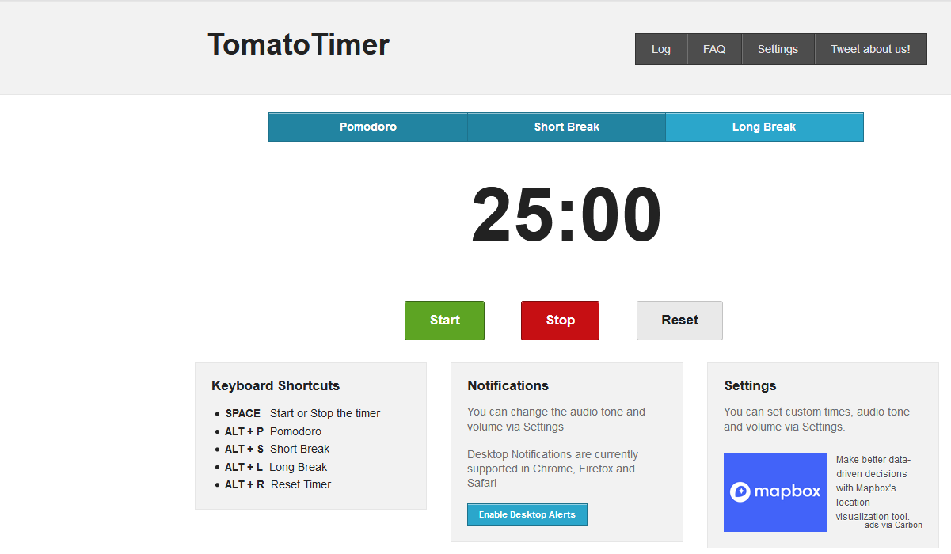

**Course 03: Time Management Activities**

**Activity 1: For each set of three statements below, circle the number of the one that best describes you:**

1. I like my watch to be set exactly at the correct time.
2. I like my watch to be set a few minutes ahead of the correct time.
3. Most of the time, I don't wear a watch.
4. I tend to arrive at most functions at least 5 minutes early.
5. I tend to arrive at most functions exactly on time.
6. I tend to arrive at most functions a little late.
7. In the course of my daily activities I tend to walk and talk quite fast.
8. In the course of my daily activities I tend to take my time.
9. In the course of my daily activities I tend to walk and talk quite slowly.
10. In high school I almost always complete my assignments.
11. In high school I usually complete my assignments.
12. In high school I often fail to complete my assignments.
13. I rarely spend more than 15 minutes at a time on my mobile.
14. I sometimes spend more than 15 minutes at a time on my mobile.
15. I often spend more than 15 minutes at a time on my mobile.
16. I like to finish assignments and reports with a little time to spare.
17. I like to finish assignments and reports exactly on their due dates.
18. I sometimes finish assignments and reports a little late.
19. I rarely spend more than an hour eating a meal.
20. I sometimes spend more than an hour eating a meal.
21. I usually spend more than an hour eating a meal.
22. I never watch more than 1 1/2 hours of TV on a weeknight.
23. I sometimes watch more than 1 1/2 hours of TV on a weeknight.
24. I usually watch more than 1 1/2 hours of TV on a weeknight.
25. I never spend more than an hour on the internet surfing or chatting at any one time.
26. I sometimes spend more than an hour on the internet surfing or chatting at one time.
27. I usually spend more than an hour on the internet surfing or chatting at one time.

Now add up the numbers that you have circled __________________

**Activity 2:**

Each week has 168 hours (24 hours X 7 days). Analyse how much time you spend in an average week on sleep, leisure, meals, chores, exercise, transportation, work, family responsibilities, classes and studying. Look at the following example of a time analysis:

Hours per activity in a seven-day week

* Sleep 56 hours
* Leisure/free time 8 hours
* Meals 14 hours
* Chores 5 hours
* Exercise 5 hours
* Transportation 5 hours
* Work 15 hours
* Family 5 hours
* Classes 30 hours
* Studying 15 hours
* Total **158 hours**

In this example, 158 of the 168 hours a week are committed, leaving 10 hours of **flexible time.** Flexible time is important so you can deal with unexpected pleasant events such as being given tickets to a concert, or unpleasant events such as getting sick.

Without flexible time, you may find it difficult to catch up those hours you lose when you are sick. Also, sometimes things take longer than you anticipated. With flexible time, you can catch up with your textbook reading even though your assignment takes longer than you expect.

Make sure you have enough flexible time to easily juggle commitments and avoid stress caused by a too tightly planned schedule. Without this time, you may not be able to keep working towards your goals, and you may have to re-examine them, prioritize them and postpone the less important.

Now complete your own time analysis. How much flexible time do you have?

|  |  |
| --- | --- |
| **Activity** | **Hours per week** |
| Sleep | |
| Leisure/free time | |
| Meals | |
| Chores | |
| Exercise | |
| Transportation | |
| Work | |
| Family | |
| Classes | |
| Studying | |
| ***Total*** | |

**Course 04: The Importance of Scheduling**

***“Everything becomes urgent if you wait long enough” ---Danny Cox***

**What is scheduling?**

Scheduling is the art of planning your activities so that you can achieve your goals and priorities in the time you have available. Creating a study schedule is a time management method that can reduce a student's level of stress by teaching them how to set aside the necessary amount of time for studying, and also how to use that time wisely. Some people may see scheduling their time as constricting, when in reality it provides a sense of freedom.  Knowing what you have to do and when you will accomplish it, allows you to know that you will be able to get everything done.  You can now enjoy your down time without feeling guilty!

Your body and your mind function best if you follow a schedule that is relatively consistent and regular.  Getting dramatically different amounts of sleep from night to night and waking up at very different times is confusing for your system.  Students who follow a regular and predictable schedule of sleep, study, meal-times, and exercise report a better quality of life and are, in general, more successful throughout their college careers.

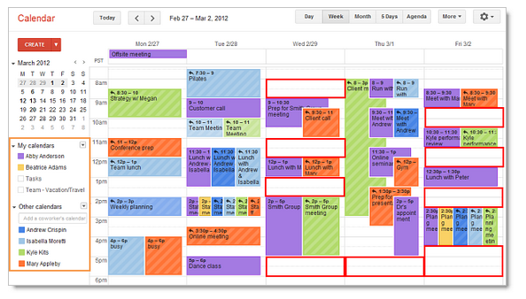**Principles**

1. Know yourself
2. Complete difficult tasks first.
3. Use daylight hours.
4. Use time before and after class.
5. Avoid too much detail
6. Know your sleep patterns.
7. Maintain a healthy lifestyle

**How to schedule your time?**

Set a regular time to do your scheduling – at the start of every week or month, for example. There are a number of different tools to choose from. A simple and easy way to keep a schedule is to use a pen and paper, organizing your time using a weekly planner. You can also use apps and software such as Google Calendar. Once you have decided which tool you want to use, prepare your schedule in the following way:

1. **Fill in everything that happens every week.**
2. **Photocopy your schedule.**
3. **Make a To Do list for the week.**
4. **Make your plan.**
5. **Revise as needed.**

**Some tips:**

1. Place the calendar or printed schedule in a visible location so that it is easy to see and follow.
2. When writing dates on a physical calendar, use a pencil so that it is easy to make changes if needed.
3. Schedules should be created so that the study times are consistent each day, which will help create positive study habits.
4. Color coded schedules are often easier to see and follow.

**Activity: Weekly Schedule**

Students have to fill a series of weekly schedules in which they plan everything they intend to do during the weeks of a whole month. At the end, a class debate will take place in order to check whether the scheduling technique has been beneficial for the student. They may use the following template.

**Weekly Schedule**

|  |  |  |  |  |  |  |  |
| --- | --- | --- | --- | --- | --- | --- | --- |
|  | **Sunday** | **Monday** | **Tuesday** | **Wednsday** | **Thursday** | **Friday** | **Saturday** |
| **6-7am** |  |  |  |  |  |  |  |
| **7-8 am** |  |  |  |  |  |  |  |
| **8-9 am** |  |  |  |  |  |  |  |
| **9-10 am** |  |  |  |  |  |  |  |
| **10-11 am** |  |  |  |  |  |  |  |
| **Noon** |  |  |  |  |  |  |  |
| **1-2 pm** |  |  |  |  |  |  |  |
| **2-3 pm** |  |  |  |  |  |  |  |
| **3-4 pm** |  |  |  |  |  |  |  |
| **4-5 pm** |  |  |  |  |  |  |  |
| **5-6 pm** |  |  |  |  |  |  |  |
| **6-7 pm** |  |  |  |  |  |  |  |
| **7-8 pm** |  |  |  |  |  |  |  |
| **8-9 pm** |  |  |  |  |  |  |  |
| **9-10 pm** |  |  |  |  |  |  |  |
| **10-11 pm** |  |  |  |  |  |  |  |
| **Midnight** |  |  |  |  |  |  |  |

**Course 05:**

1. **The Eisenhower Decision Matrix**

**How to Distinguish Between Urgent and Important Tasks and Make Real Progress in Your Life**

**“What is important is seldom urgent and what is urgent is seldom important.”**

At the end of the day do you feel completely sapped and drained of energy, and yet can’t point to anything you accomplished of real significance?

### The Difference between Urgent and Important

**Urgent** means that a task requires immediate attention. These are the to-do’s that shout “Now!” Urgent tasks put us in a *reactive* mode, one marked by a defensive, negative, hurried, and narrowly-focused mindset.

**Important** tasks are things that contribute to our long-term mission, values, and goals. Sometimes important tasks are also urgent, but typically they’re not. When we focus on important activities we operate in a *responsive* mode, which helps us remain calm, rational, and open to new opportunities.

It’s a pretty intuitive distinction, yet most of us frequently fall into the trap of believing that all urgent activities are also important. Modern technologies (24-hour news, Twitter, Facebook, text messaging) that constantly bombard us with information have only heightened this deeply engrained mindset. Our stimulus-producing tech treats all information as equally urgent and pressing.

Business thinker Stephen Covey popularized the Eisenhower’s Decision Principle in his book, [***The 7 Habits of Highly Effective People***](http://www.amazon.com/gp/product/0743269519?ie=UTF8&tag=stucosuccess-20&linkCode=as2&camp=1789&creative=390957&creativeASIN=0743269519)***.*** In that book, Covey created a decision matrix to help individuals make the distinction between what’s important and not important and what’s urgent and not urgent. The matrix consists of a square divided into four boxes, or quadrants, labeled thusly: 1) Urgent/Important, 2) Not Urgent/Important, 3) Urgent/Not Important, and 4) Not Urgent/Not Important:

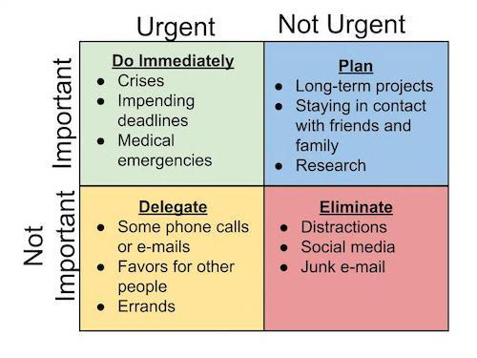

**Quadrant 1** tasks are both urgent and important. They’re tasks that require our immediate attention and also work towards fulfilling our long-term goals and missions in life. With a bit of planning and organization, many Q1 tasks can be made more efficient or even eliminated outright. For example, instead of waiting until the last minute to work on a term paper (thus turning it into an urgent task), you could schedule your time so that you’re done with your paper a week in advance.

**Quadrant 2** tasks are the activities that don’t have a pressing deadline, but nonetheless help you achieve your important personal, school, and work goals as well as help you fulfill your overall mission as a student. According to Covey, **we should seek to spend most of our time on Q2 activities**, as they’re the ones that provide us lasting happiness, fulfillment, and success.

Because Q2 activities aren’t pressing for our attention, we typically keep them forever on the backburner of our lives and tell ourselves, “I’ll get to those things ‘someday’ after I’ve taken care of this urgent stuff.” We even put off figuring out what’s most important in life, which of course only perpetuates a cycle where all we ever take care of are the most urgent to-dos on our list.

**Quadrant 3** tasks are activities that require our attention now (urgent), but don’t help us achieve our goals or fulfill our mission (not important). Most Q3 tasks are interruptions from other people and often involve helping them meet their own goals and fulfill their own priorities.

People who spend most of their time working on Urgent but Not Important Tasks often suffer from “Nice Guy Syndrome,” and want to constantly please others at the expense of their own happiness. If that’s you, the solution is simple: [Become more assertive](http://www.artofmanliness.com/2013/02/12/how-to-be-assertive/) and start to firmly (but politely) [say no to most requests](http://www.artofmanliness.com/2010/08/29/how-to-firmly-say-no-without-coming-off-like-a-jerk/).

**Quadrant 4** activities aren’t urgent and aren’t important. They aren’t pressing nor do they help you achieve long-term goals or fulfill your mission as a man. They’re primarily distractions. Instead of aiming to completely rid yourself of Not Urgent and Not Important tasks, try to only spend a very limited amount of time on them. 5% or less of your waking hours is a good goal.

If you spend most of your time working on **Not Urgent but Important tasks**, you’ll feel a renewed sense of calm, control, and composure in your life. You’ll feel like you’re making real progress. By investing your time in Q2’s planning/organizing activities, you can prevent and eliminate many of the crises and problems of Q1, balance the requests of Q3 with your own needs, and truly enjoy sitting and relaxing of Q4, knowing that you’ve earned the rest. By making Q2 tasks your top priority, no matter the emergency, annoyance, or deadline you’re hit with, you’ll have the mental, emotional, and physical wherewithal to respond positively, rather than react defensively.

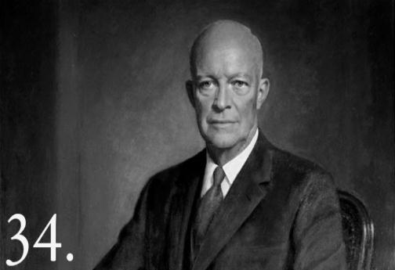Dwight D. Eisenhower was the 34th President of the United States from 1953 until 1961. Before becoming President, he served as a general in the United States Army and as the Allied Forces Supreme Commander during World War II. He also later became NATO’s first supreme commander. Dwight had to make tough decisions continuously about which of the many tasks he should focus on each day. This finally led him to invent the world-famous Eisenhower principle, which today helps us prioritize by urgency and importance.

1. **The Ivy Lee Method**
2. At the end of each work day, write down the six most important things you need to accomplish tomorrow. Do not write down more than six tasks.
3. Prioritize those six items in order of their true importance.
4. When you arrive tomorrow, concentrate only on the first task. Work until the first task is finished before moving on to the second task.
5. Approach the rest of your list in the same fashion. At the end of the day, move any unfinished items to a new list of six tasks for the following day.
6. Repeat this process every working day.

**Course 06: Overcoming Procrastination**

“You may delay but time will not, and lost time is never found again”

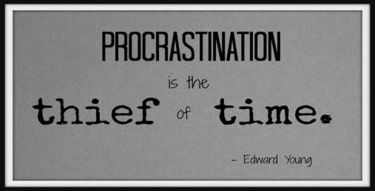**Benjamin Frankl**in

1. **Definition :**

Procrastination is a complex psychological behavior that affects everyone to some degree or another. With some it can be a minor problem; with others it is a source of considerable stress and anxiety. Procrastination is related to time management, (procrastinators often know exactly what they should be doing, even if they cannot do it), which is why very detailed schedules usually are no help.

1. **Simple Reasons of Procrastination:**
2. ***Difficult***- the task seems hard to do; we naturally tend to avoid difficult things in favor of those which seem easy to us.

***b.*** ***Time-consuming***- the task will take large blocks of time, and large blocks of time are unavailable until the weekend.

***c.*** ***Lack of knowledge or skills*** - no one wants to make mistakes, so wait until you learn how before you start.

***d.*** ***Fears***- everyone will know how you screwed up.

**Cure: DO EVERYTHING OPPOSITE**

1. **Complex Reasons of Procrastination:**
2. **Perfectionism: Everything must go completely right.**

**Dissatisfaction and Frustration**

“I must do everything right the first time.” “If you can’t do it right, don’t do it at all.”

**b. Anger / Hostility:** if you are upset with a professor, you are likely to delay in starting a demanding project.

**c. Low Frustration Tolerance:** whining and complaining**:** “it isn’t fair,” “this is too hard,”

**d. Self-Downing:** minimizing one’s skills, and expressing doubt about ability to succeed.

1. **Overcoming Procrastination:**
2. 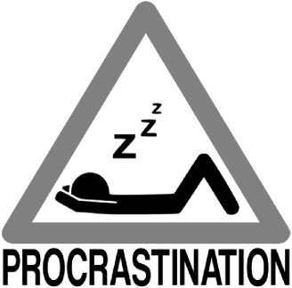Nurturing self-confidence: Perfection does not exist
3. Organization: A to-do list: priorities
4. Concentration: getting rid of external interferences.
5. Splitting up work
6. Self-Rewarding
7. Living healthily
8. Modifying environment
9. Using a good friend as positive role model

**Activity:**

Each of these rationalizations needs to be argued against and defeated so that you can experience success. Write a rebuttal for each one.

1. “I’m more productive when I work under pressure, so I’m postponing all my work until the pressure builds up and then I’ll get it done easily.”

2. “I don’t know how to do this problem, so I’m waiting until I know how before I do it.”

3. “This task isn’t getting done because I really don’t want to do it. And that’s the honest truth”

4. “Relax. The world isn’t going to come to an end if this doesn’t get done.”

5. “This job is easier to do when I’m in the mood, and I’m simply not in the mood right now.”

6. “I waited until the last moment before and it worked out okay, so why not this time?”

7. “If I wait until the last minute, I won’t spend so much time on it.”

8. “If I do this work right now, I’ll miss out on a once-in-a-lifetime social event.”

9. “Circumstances beyond my control prevented me from doing so.”

10. “I’ve worked on this for so long that I have no interest or energy for it.”

**Activity 2: How good is your time management?**

|  |  |  |  |  |  |
| --- | --- | --- | --- | --- | --- |
| **Statement to answer** | **Not at All** | **Rarely** | **Sometimes** | **often** | **Very Often** |
| **1.** The tasks I work on are the ones with the highest priority. |  |  |  |  |  |
| **2.** I find myself completing tasks at the last minute, or asking for extensions. |  |  |  |  |  |
| **3.** I set aside time for planning and scheduling. |  |  |  |  |  |
| **4.** I know how much time I spend on each of the various task I do. |  |  |  |  |  |
| **5.** I find myself dealing with interruptions. |  |  |  |  |  |
| **6.** I use goal setting to decide what tasks and activities I should work on. |  |  |  |  |  |
| **7.** I leave contingency time in my schedule to deal with "the unexpected"? |  |  |  |  |  |
| **8.** I know whether the tasks I am working on are high, medium, or low value. |  |  |  |  |  |
| **9.** When I am given a new assignment, I analyze it for importance and prioritize it accordingly. |  |  |  |  |  |
| **10.** I am stressed about deadlines and commitments. |  |  |  |  |  |
| **11.** Distractions keep me from working on critical tasks. |  |  |  |  |  |
| **12.** I have to take work home in order to get it done. |  |  |  |  |  |
| **13.** I prioritize my To Do list or Action Program. |  |  |  |  |  |
| **14.** I confirm my priorities with my boss. |  |  |  |  |  |
| **15.** Before I take on a task, I check that the results will be worth the time put in. |  |  |  |  |  |

### Goal Setting: (Questions 6, 10)

### Prioritization: (Questions 1, 4, 8, 13, 14, 15)

### Managing Interruptions:  (Questions 5, 9, 11, 12)

### Procrastination: (Questions 2)

### Scheduling: (Questions 3, 7)

**Activity 3: Are you a procrastinator?**

|  |  |  |  |  |  |
| --- | --- | --- | --- | --- | --- |
| **Statement to answer** | **Not like me at all** | **Not like me** | **Neither like me or not** | **Like me** | **Very like me** |
| 1. I often find myself performing tasks that I had intended to do days before. |  |  |  |  |  |
| 1. When planning what to do, I make the necessary arrangements well in advance. |  |  |  |  |  |
| 1. I generally return emails and phone calls promptly. |  |  |  |  |  |
| 1. I find that jobs often don't get done for days, even when they require little else except sitting down and doing them. |  |  |  |  |  |
| 1. Once I have the information I need, I usually make decisions as soon as possible. |  |  |  |  |  |
| 1. When I have something difficult to do, I tell myself that it's better to wait to do it until I'm feeling more inspired. |  |  |  |  |  |
| 1. I usually have to rush to complete tasks on time. |  |  |  |  |  |
| 1. I usually accomplish all the things I plan to do in a day. |  |  |  |  |  |
| 1. I usually start a task I'm given shortly after I'm given it. |  |  |  |  |  |
| 1. When deadlines are approaching, I often waste time by doing other things. |  |  |  |  |  |
| 1. I often have a task finished sooner than necessary. |  |  |  |  |  |
| 1. When preparing for what to do, I am seldom caught having to do something at the last minute. |  |  |  |  |  |
| 1. I often delay starting tasks that I have to do. |  |  |  |  |  |
| 1. When faced with a huge task, I figure out what the first step is so that I can get going. |  |  |  |  |  |
| 1. I frequently say "I'll do it tomorrow". |  |  |  |  |  |

(Source: Procrastination Scale by Prof. Clarry Lay, York University, Canada, 1986)

**Course 07: Overcoming Stress**

**A/ Definitions:**

1. A worried or nervous feeling that stops you relaxing, caused, for example, by pressure at work or financial or personal problems. (MACMILLAN English Dictionary)
2. A state of mental or emotional strain or tension resulting from adverse or demanding circumstances.

*‘he's obviously under a lot of stress’, ‘the stresses and strains of being a parent’* (OED)

1. Great [worry](https://dictionary.cambridge.org/dictionary/english/worry) [caused](https://dictionary.cambridge.org/dictionary/english/cause) by a [difficult](https://dictionary.cambridge.org/dictionary/english/difficult) [situation](https://dictionary.cambridge.org/dictionary/english/situation), or something that [causes](https://dictionary.cambridge.org/dictionary/english/cause) this [condition](https://dictionary.cambridge.org/dictionary/english/condition):

People under a lot of stress may [experience](https://dictionary.cambridge.org/dictionary/english/experience) [headaches](https://dictionary.cambridge.org/dictionary/english/headache), [minor](https://dictionary.cambridge.org/dictionary/english/minor) [pains](https://dictionary.cambridge.org/dictionary/english/pains), and [sleeping](https://dictionary.cambridge.org/dictionary/english/sleep) difficulties. (CED)

1. “Stress is a condition or feeling experienced when a person perceives that demands exceed the personal and social resources the individual is able to mobilize." (Richard. S. Lazarus,1999)

B/ **Fight or Flight Response**

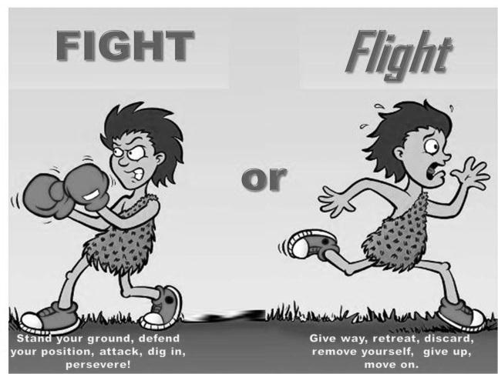Some of the early research on stress (conducted by Walter Cannon in 1932) established the existence of the well-known "fight-or-flight" response. His work showed that when an organism experiences a shock or perceives a threat, it quickly releases hormones that help it to survive. When the threat is small, our response is small and we often do not notice it among the many other distractions of a stressful situation.

C/ **Negative Consequences**

* We are excitable, anxious, jumpy and irritable.
* It reduces our ability to work effectively with other people.
* With trembling and a pounding heart, we can find it difficult to execute precise, controlled skills.
* We find ourselves more accident-prone and less able to make good decisions.
* Problems of poor health and burnout.

Stress impacts our ability to do our jobs effectively, and it affects how we work with other people. This can have a serious impact on our studies, careers, and well as on our general well-being and relationships. Long-term stress can also cause conditions such as burnout, cardiovascular disease, stroke, depression, high blood pressure, and a weakened immune system.

Burnout occurs when passionate, committed people become deeply disillusioned with a job or career from which they have previously derived much of their identity and meaning. It comes as the things that inspire passion and enthusiasm are stripped away, and tedious or unpleasant things crowd in.

D/ **Signs of Stress**

* Frequent headaches.
* Cold or sweaty hands and feet.
* Frequent heartburn, stomach pain, or nausea.
* Panic attacks.
* Excessive sleeping, or insomnia,
* Persistent difficulty concentrating.
* Obsessive or compulsive behaviors.
* Social withdrawal or isolation.
* Constant fatigue.
* Irritability and angry episodes.
* Significant weight gain or loss.
* Consistent feelings of being overwhelmed or overloaded.

F/ **How to Manage Stress**

*The first step in managing stress is to understand **where these feelings are coming from.**

*Next, list the stressors in order of their impact.

* Which affect your health and well-being most?
* And which affect your work and productivity?

***According to:* www.medicinenet.com*, there are 10 ways to stop stress:***

-Research suggests that chewing gum can help relieve both stress and anxiety.

-Studies show that spending a few minutes outside, even close to home, can provide a mood boost.

-Smiling when you feel stressed creates a little tension in facial muscles that helps reduce stress.

### -Sniff Some Lavender.

### -Tune in. Music can help keep you calm.

### -Breathing exercises are one way to quickly stop the stress response.

### -Be kind to yourself.

### -Writing about your problems in a journal can help you feel calmer and help you arrive at solutions you hadn’t thought of before.

### -Get together with friends or loved ones when you’re feeling stressed.

-Exercise benefits mood in many ways.

**Getting Informed**

**Course 08:**

1. **Defining information**
2. The communication or reception of knowledge or intelligence.
3. Knowledge obtained from investigation, study, or instruction.
4. It is the answer to a question of some kind.
5. Information is conveyed either as the content of a message or through direct or indirect observation of anything.
6. Information can be [encoded](https://en.wikipedia.org/wiki/Code) into various forms for [transmission](https://en.wikipedia.org/wiki/Transmission_(telecommunications)) and [interpretation](https://en.wikipedia.org/wiki/Language_interpretation).
7. Information reduces [uncertainty](https://en.wikipedia.org/wiki/Uncertainty). The more uncertain an event, the more information is required to resolve uncertainty of that event.
8. The noun ‘information’ is derived from the verb ’informare’’ which means ‘to form an idea of’, ‘to instruct’, ‘to teach’.
9. Facts provided or learned about something or someone.
10. We get, obtain, collect, give, provide, share relevant or useful information on, about or regarding…
11. Information overload: a situation in which you get more information than you can deal with at one time and become tired and confused.
12. Information theory, information technology, the information superhighway.
13. An informed choice /decision: based on good knowledge of something.
14. An informed debate: involving people who have a lot of knowledge.
15. The concepts of : paperless office, informatization, information society (17 may), digital divide.
16. **Types of Information Sources**

Information can come from virtually anywhere — media, blogs, personal experiences, books, journal and magazine articles, expert opinions, encyclopedias, and web pages — and the type of information you need will change depending on the question you are trying to answer.

|  |  |  |  |
| --- | --- | --- | --- |
| **Type** | **Information** | **Use** | **Example** |
| **Magazine** | A magazine is a collection of articles and images about diverse topics of popular interest and current events. Usually these articles are written by journalists or scholars and are geared toward the average adult. Magazines may cover very "serious" material, but to find consistent scholarly information, you should use journals. | * to find information or opinions about popular culture * to find up-to-date information about current events * to find general articles for people who are not necessarily specialists about the topic | * *National Geographic* * *Ebony* * *Sports Illustrated* * *People* |
| **Journal** | A journal is a collection of articles usually written by scholars in an academic or professional field. An editorial board reviews articles to decide whether they should be accepted. Articles in journals can cover very specific topics or narrow fields of research. | * when doing scholarly research * to find out what has been studied on your topic * to find bibliographies that point to other relevant research | * Journal of Communication * The Historian * Journal of the American Medical Association * Lancet |
| **Database** | A database contains citations of articles in magazines, journals, and newspapers. They may also contain citations to podcasts, blogs, videos, and other media types. Some databases contain abstracts or brief summaries of the articles, while other databases contain complete, full-text articles. | when you want to find articles on your topic in magazines, journals or newspapers | * Academic Search Complete (a general database) * Compendex (an engineering database) * ABI/Inform (a business database) |
| **Newspaper** | A newspaper is a collection of articles about current events usually published daily. Since there is at least one in every city, it is a great source for local information. | * to find current information about international, national and local events * to find editorials, commentaries, expert or popular opinions | *New York Times* |
| **Library catalog** | A library catalog is an organized and searchable collection of records of every item in a library and can be found on the library home page. The catalog will point you to the location of a particular source, or group of sources, that the library owns on your topic. | * to find out what items the library owns on your topic * to find where a specific item is located in the library | Virginia Tech's library catalog is called Addison. |
| **Book** | Books cover virtually any topic, fact or fiction. For research purposes, you will probably be looking for books that synthesize all the information on one topic to support a particular argument or thesis.  Libraries organize and store their book collections on shelves called "stacks." | * when looking for **lots** of information on a topic * to put your topic in context with other important issues * to find historical information * to find summaries of research to support an argument. | * Nash, Gary B. ed. *The American People: Creating a Nation and a Society,* 1990. * Silverstone, Roger, ed. *Visions of Suburbia,* 1997. * Smith, J. T. *Roman Villas: A Study in Social Structure,* 1997 |
| **Encyclopedia** | Encyclopedias are collections of short, factual entries often written by different contributors who are knowledgeable about the topic.  There are two types of encyclopedias: general and subject. General encyclopedias provide concise overviews on a wide variety of topics. Subject encyclopedias contain in-depth entries focusing on one field of study. | * when looking for background information on a topic * when trying to find key ideas, important dates or concepts | * *African-American Encyclopedia* (subject encyclopedia) * *Encyclopedia Americana* (general encyclopedia) * *World Book* (general encyclopedia found online) |
| **Web site** | The Web allows you to access most types of information on the Internet through a browser. One of the main features of the Web is the ability to quickly link to other related information. The Web contains information beyond plain text, including sounds, images, and video. The important thing to do when using information on the Internet is to know how to evaluate it. | * to find current information * to find both expert and popular opinions * to find information about hobbies and personal interests | wikipedia.org (a wiki) |

**Course 09: Library documentation**

1. **What is a library?**
2. A place in which literary, musical, artistic, or reference materials (such as books, manuscripts, recordings, or films) are kept for use but not for sale. (Merriam Webster Dcitionary)
3. A building or room containing collections of books, periodicals, and sometimes films and recorded music for use or borrowing by the public or the members of an institution. *‘a university library’(OED)*
4. George Eberhart (2010) offers this definition: "A library is a collection of resources in a variety of formats that is (1) organized by information professionals or other experts who (2) provide convenient physical, digital, bibliographic, or intellectual access and (3) offer targeted services and programs (4) with the mission of educating, informing, or entertaining a variety of audiences (5) and the goal of stimulating individual learning and advancing society as a whole." (p.1)
5. “Library -- from the Latin liber, meaning "book." In Greek and the Romance languages, the corresponding term is bibliotheca. A collection or group of collections of books and/or other print or non-print materials organized and maintained for use (reading, consultation, study, research, etc.).” (ODLIS)
6. **Types of Libraries:**
7. ***Academic library***: serves the university, its students, staff and faculty.
8. ***Public library***: serves different types of communities. It is considered as an essential part of having educated and literate population. It serves the general public’s information needs. Users can borrow books and other materials.
9. ***School library***: also called media center, serves students, teachers and sometimes parents who can access to a variety of resources. A school library may have a considerable impact on the students’ achievements when it serves as a learning space for students to look for information, use computers, and do independent work.
10. ***Special library***: serves specialized and limited populations. It can include medical library, museum library, library, military library, music library, or law library…etc
11. **The Advantages of a Library**

The very concept of the library is kind of an amazing one. Where else can someone borrow an item of value, with only a card and a promise to return it, for free? People value libraries as enjoyable, recreational and academic additions to their communities. A library offers a wealth of resources, space to study or hold events, and a world of books to discover and borrow. It encourages scholarship and offers a quiet, peaceful place of study, which is tough to find in urban areas.

**Group work 1: A Visit to Library**

A group of three or four students visits a library, whether public, academic, school or special and makes a survey. The results of the visit will be presented orally in class.



**Course 10:** **Libraries vs. the Internet**

***Libraries...A Very Brief History***

1450: Johann Gutenberg invents moveable type. Books are now printed instead of handwritten.

1833: The first public library opens in New Hampshire.

1876: Librarians, led by Melvil Dewey, establish the American Library Association (ALA). That same year, Dewey copyrights his Dewey Decimal System, a book-classification system.

1883-1929: Andrew Carnegie builds 2,509 public libraries in the United States, allowing Americans full access to library services.

1960s: School libraries undergo substantial development, thanks to money from public funding for education.

2015: The ALA estimates that there are 119,487 libraries of all kinds in the United States.

***The Internet...A Very Brief History***

*1957: The USSR launches Sputnik into orbit, enabling global communications.*

*1958: Bell Labs invents the modem, which allows communication between computers.*

*Jan 1, 1983: Considered the "official birthday" of the Internet, a term coined by pioneers Vint Cerf and Robert Kahn.*

*1989: Computer scientist Tim Berners Lee creates the World Wide Web (WWW).*

*1991: The World Wide Web is made public. Many search engines are created during this decade.*

*1991: Politician Al Gore's High-Performance Computing and Communications Act provides $600 million for computer-network research and development. An "Information Superhighway" is created.*

*2017: By April of this year, more than 3.8 billion people globally use the Internet. This is more than half of the world's population.*

***Should we use the library or the internet?***

1. The Internet is available for research 24 hours a day, 7 days a week. Although some libraries offer online services, the library itself is not always available.
2. Researchers can find web sites on the Internet that offer text, video, audio, photos, graphics, and other multimedia. Libraries house multimedia, but they are not necessarily found all in one place.
3. The information on the Internet is more up-to-date and timely. Web site content can be updated with the newest information.
4. Keyword searches via an Internet search engine uncover a large variety of web sites on and many differing opinions about a topic.
5. Many newsgroups, social media sites, and question-and answer forums are available on the Internet, providing ways for quick feedback from an online community.
6. Some newspapers, journals, magazines, and encyclopedias offer full content on the Internet, rivaling content that is available at libraries.
7. You can find an answer very quickly on the Internet to many questions. It may take longer if you look for answers to those same questions in a library.
8. On the Internet, you can research from home or from a variety of locations, if access is available.
9. The library has access to more journals and books. According to the ALA, the Internet provides only 8% of all journals, and an even lower percentage of all books are available.
10. Librarians are trained professionals and can assist researchers. On the Internet, you are on your own.
11. Libraries catalog and organize all materials, making research easy. Internet search engines do not have access to all Internet content, and the content available is not organized.
12. Libraries house archived materials and content. Content more than 15 years old can be difficult to find on the Internet.
13. Sources found at the library are easy to identify. Not all sources found on the Internet are identifiable, and thus not reliable.
14. Libraries offer free access to content, including journals, magazines, newspapers, encyclopedias, and more. Some Internet content is subscription-based.
15. Researchers have access to physical books. Studies show that the majority of readers prefer reading physical books to online materials.
16. Most online library content is free of advertisements, unlike most free Internet content.

**Reading Skills and Strategies**

**Course 11:**

1. **What is Reading?**

The act of reading refers, more specifically, to one’s ability to use one’s vision to interpret graphic symbols. It is therefore a visual process. (Dechant, 1991 as cited in Macceca, 2007, p. 4)

Such process is commonly referred to as a **decoding, deciphering or identifying process.**

“Unless we can recognize the written words, we cannot even begin to read.” (Nuttall, 2005, p. 2)

Reading means also articulation and pronunciation. Nuttall (2005) argues that «in a great many classrooms, the reading lesson is used as an opportunity to teach pronunciation, practice fluent and expressive speaking… For early readers, again, reading aloud is important: they have to discover how writing is associated with the spoken words they already use” (p. 2)

Very often, when reading we are not interested in the pronunciation and the grammatical structure.

We read because we want to get something from the writing. It is the message which can be facts, ideas, or feelings. It is the writer’s intention(s). We are interested in meaning which is transferred from mind to mind, from a writer to a reader.

1. **Reading and the Communication Process**

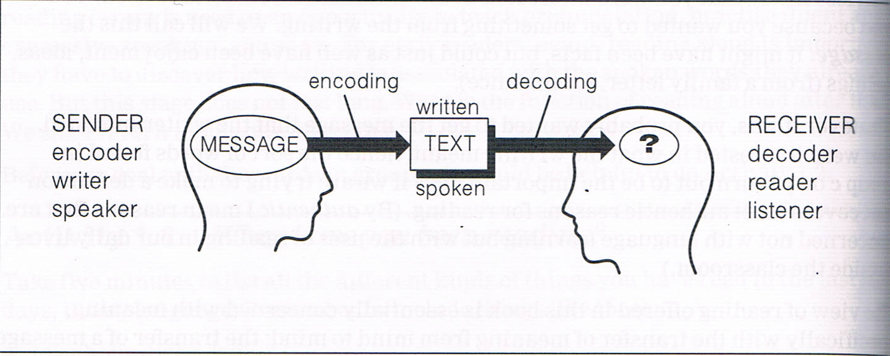

1. **Is the reader’s role passive?**

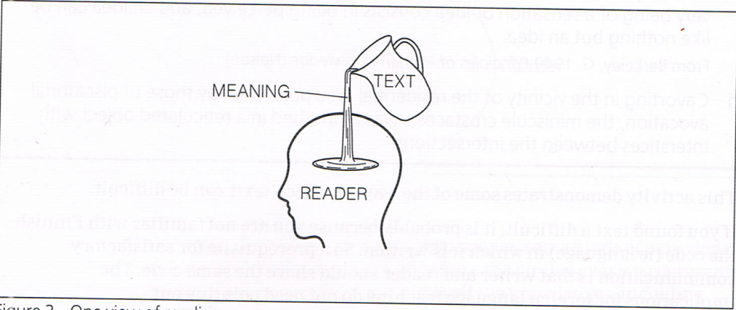

“The text is full of meaning like a jug full of water; the reader’s mind soaks it up like a sponge. In this view, the reader’s role is passive; all the work has been done by the writier and the reader has only to open his mind and let the meaning pour in.” (Nuttall, 2005, p. 5)

1. **What makes a text difficult?**

**Activity 1**

*Here are four texts that you may find difficult to read. They are difficult in different ways; study each in turn and decide in each case what makes the text difficult.*

**Text 1:**

lstuin eräänä tammikunn loppupäiväna Tiitin kanssa Kokkolasta Jyväskylään kulkevassa linja-autossa. Oli kirpeä pakkasilma, taivas oli kirkas, Ja aurinko heitti lumhangiille ja tien poikki puiden pitkeä sinsiä varjoja.

**Text 2:**

In the first example, a carbon anion is formed that is stabilized by resonance (electrons delocalized over the carbonyl group and the α carbon atom). In the second case, a carbon anion is formed that is stabilized by the electron withdrawing inductive effect of the three chlorines.

**Text 3:**

Ideas imprinted on the senses are real things, or do really exist, this we do not deny, but we deny that they can subsist without the minds which perceive them, or that they are resemblances of any archetypes existing without the mind: since the very being of a sensation or idea consists in being perceived, and an idea can be like nothing but an idea.

**Text 4:**

Cavorting in the vicinity of the residential area populated by those of piscatorial avocation, the miniscule crustacean was enmeshed in the reticulated object with interstices between the intersections

**So,**

The reader and writer should have certain things in common. If communication has to take place, they have to share a code. They write and understand the same language. They must have the same command of the language. It is hard for the reader to understand if his vocabulary is smaller than the writer’s. They should share certain assumptions about the world and the way it works. The writer expects the reader to share his/her views, ideas, and feelings.

1. **Interactive Reading**

**Activity2:**

*Study the following text and make as many possible assumptions and interpretations*

**The bus careered along and ended up in the hedge. Several passengers were hurt. The driver was questioned by the police**.

* **To career**: to move forwards very quickly in an uncontrolled way.
* **Hedge**: a line of bushes or small trees growing close together around a garden or field.

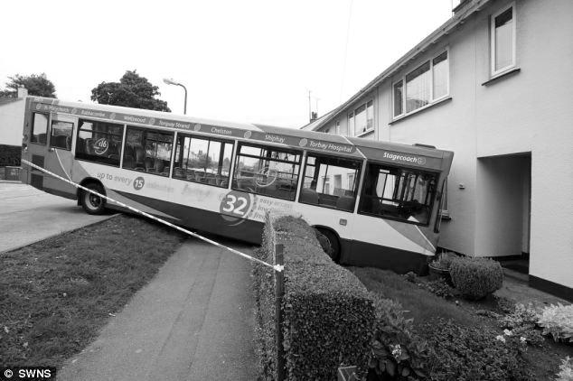

1. **Active involvement of the reader**

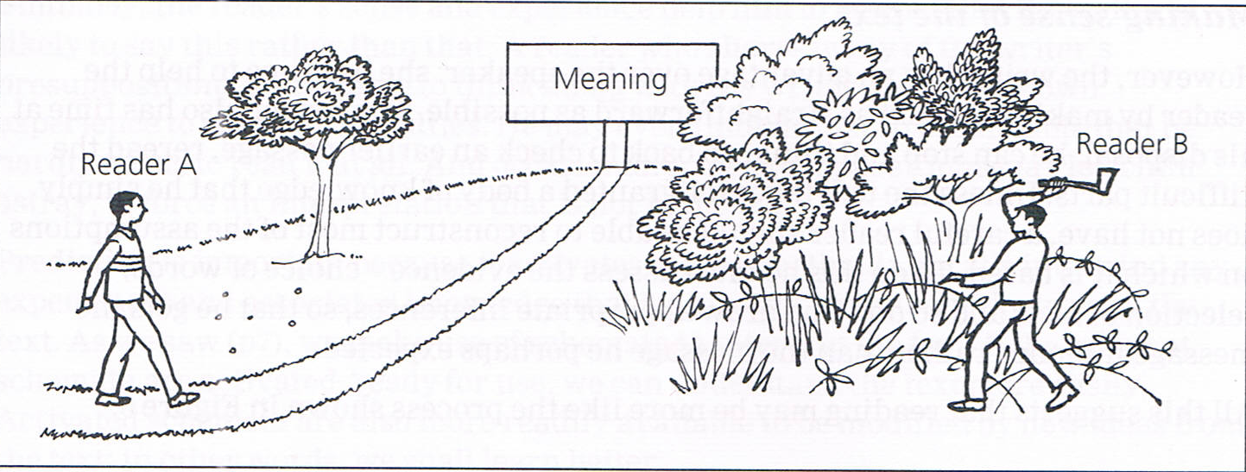

**Course 12: Reading Skills and Strategies**

***7 Ways Reading Aloud Improves and Enriches Your Life***

**By** [**Stephanie Ciccarelli**](https://www.voices.com/blog/author/stephanie/)**- September 6, 2018**

**(Source:** [**www.voices.com**](http://www.voices.com)**)**

How can reading aloud improve your life and also make you a better voice actor?

When you read aloud, you’re employing a great number of your faculties, and more often than not, the very act of reading aloud is a revelation in itself. However, for voice actors, reading aloud is the very basis of your craft.

Here are 7 benefits of reading aloud to motivate you to get started. This wonderful practice will help you build up your voice skills and become (more) successful as a voice actor.

## Reading Aloud:

1. Sharpens Your Focus
2. Increases Your Vocabulary
3. Results in Greater Comprehension
4. Gives you an Opportunity to Play
5. Exercises Your Body
6. Challenges Your Use of Intonation
7. Improves Listening and Reading Skills

## 1. Sharpens Focus

## When you’re reading aloud, you will find that it becomes easier to put all of your energy into the task at hand without the temptation of distractions. You are so focused that you likely won’t even notice that you are strengthening your mental and verbal skills.

## If you think about it, your mind is akin to a muscle. When it works out, you tone it and build up strength. When you read aloud, you are exercising the connection between your mind and your voice to the full extent which results in greater focus and cohesiveness.

## 2. Increases Vocabulary

Ever come across a word in a script that you are unsure of how to pronounce? Reading aloud more often, can help you become familiar with more unfamiliar word. Saying something in context aloud is very powerful.

When you are reading in your head, you only hear the words internally and their effect on you is limited to [how you interpret the script](https://www.voices.com/blog/script-interpretation-letting-the-copy-be-your-guide/) or other words during that very private experience.

If you choose to read them aloud, you may find deeper layers of meaning in the words because when they are spoken, they take on a life of their own and become a part of you. And inevitably through comprehension, become part of your vocabulary and influence your use of language.

## 3. Greater Comprehension

People learn in a variety of ways – visual, aural, tactile and so on. By reading aloud, you’ll stand a better chance of internalizing the words and making them your own before you perform.

Of course, this approach helps others who are not reading aloud as an actor, but for the sake of learning in general.

If you are an auditory learner, reading aloud will help the material to sink in and become ingrained, making it easier to draw on the information you’ve just ingested for when you need to reference it in the future.

## 4. Opportunity to Play

If you are looking for an opportunity to stretch your imagination and explore the capabilities that may be hidden in your voice, read a children’s book aloud to someone you love. Read anything you can find! From cereal boxes, to instruction manuals to [sample voice over scripts](https://www.voices.com/blog/category/tools-and-resources/sample-scripts/) – breathe life into every piece of copy you come across.

Audiobook narrator, Ilyana Kadushin, shares her [tips on learning to becoming a great speaker](https://www.voices.com/blog/becoming-an-audiobook-narrator/) and endure the challenges of reading long-form narration aloud. “Go to a senior citizen’s home or a place for the blind, or a place for children and read to people out loud and really feel what that’s like to have to sustain narration and to feel that someone’s listening,” Ilyana says. “Just feel that in your body. That, to me, is very important – to understand that someone’s listening and that what you’re doing with the language is landing in their ear.”

## 5. Exercises Your Body

When people speak, we often involve more than just our voice in the projection process. In fact, many of us, attributable to culture or otherwise, make use of our entire body when speaking to get a point across. Physical expression adds or supports what we are saying and can also help your [voice sound more engaging](https://www.voices.com/blog/6-ways-facial-expression-and-physicality-play-into-the-sound-of-a-voice/) and animated – this is especially important if you are putting on a character voice.

## 6. Challenges Your Use of Intonation

When you read aloud, sounding dull isn’t an option, especially if you have an audience. Make use of the full range of your voice. By speaking the words as though you have full intention of them being heard, you’ll be able to discover and explore your range more deeply.

If you’re wondering how you sound, try recording yourself and then playing it back, noting where your voice goes up, down, starts, stops, fluctuates and even surprises you.

## 7. Improves Listening and Reading Skills

Lastly, reading aloud will make you more aware of things that you read, hear, and also help you to identify proper grammar, sentence structure, and so forth. Reading aloud also does much for shaping your interpretation of what is being said.

You’ll be able to read with more efficiency and richness, expand your literary horizons and also experiment with the many ways you could interpret the written word, then translate your findings through spoken word expression.

**Group work N° 2**

* 1. Reading aloud
  2. Reading a short story/novella
* Each group has to practice reading aloud the following excerpt from Charlotte’s Web by E. B. White.
* Each group are free to choose and to read a short story or novella and discuss their impressions in class.

**Charlotte's Web**

**By E.B.White**

1. Before Breakfast

"Where's Papa going with the ax?" said Fern to her mother as they were setting the table for breakfast.

"Out to the hoghouse," replied Mrs. Arable. "Some pigs were born last night."

"I don't see why he needs an ax," continued Fern, who was only eight.

"Well," said her mother, "one of the pigs is a runt. It's very small and weak, and it will never amount to anything. So your father has decided to do away with it."

"Do away with it?" shrieked Fern. "You mean kill it? Just because it's smaller than the others?"

Mrs. Arable put a pitcher of cream on the table. "Don't yell, Fern!" she said. "Your father is right. The pig would probably die anyway."

Fern pushed a chair out of the way and ran outdoors. The grass was wet and the earth smelled of springtime. Fern's sneakers were sopping by the time she caught up with her father.

"Please don't kill it!" she sobbed. "It's unfair."

Mr. Arable stopped walking.

"Fer," he said gently, "you will have to learn to control yourself."

"Control myself?" yelled Fern. "This is a matter of life and death, and you talk about controlling myself." Tears ran down her cheeks and she took hold of the ax and tried to pull it out of her father's hand.

"Fern," said Mr. Arable, "I know more about raising a litter of pigs than you do. A weakling makes trouble. Now run along!"

"But it's unfair," cried Fern. "The pig couldn't help being born small, could it? If I had been very small at birth, would you have killed me?"

Mr. Arable smiled. "Certainly not," he said, looking down at his daughter with love. "But this is different. A little girl is one thing, a little runty pig is another."

"I see no difference," replied Fern, still hanging on to the ax. "This is the most terrible case of injustice I ever heard of."

A queer look came over John Arable's face. He seemed almost ready to cry himself.

"All right," he said. "You go back to the house and I will bring the runt when I come in. I'll let you start it on a bottle, like a baby. Then you'll see what trouble a pig can be."

**Course 13: Note Taking**

**A.Definition:**

Note taking refers to the short written transcription of spoken language (lecture, meeting, presentation, audiovisual document, etc.).

Important idea understanding synthesizing note taking knowledge representation

**However:**

-There is no unique recipe.

-Every student is free to choose his/ her own conventions techniques.

-It is useless to take notes of all what is said.

**B. Why take notes?**

\***take in** ideas, understand and remember something that you hear or read

*improve knowledge.

*help identify the core of important ideas.

*help to learn and remember later.

*only chance to learn.

**C.Techniques:**

1. Make some preparation beforehand.
2. Copy everything on the blackboard, especially the **outline**.
3. Listening well = paying close attention.
4. Have paper and pencil or pen ready.
5. Write down the title name of the course and the date.
6. Recognize main ideas by signal words
7. Jot down details or examples that support the main ideas.
8. If there is a summary at the end of the lecture, pay close attention to it.
9. Ask questions about points you did not understand.
10. Don't be in a rush. Be attentive, and listen carefully.
11. Revise your notes as quickly as possible, preferably immediately after the lecture.
12. Review the lecture notes before the next lecture.

**D. Tips on taking notes:**

a. Do not doodle or play with your pen. These activities break eye contact and concentration.

b. Enter your notes legibly because it saves time. Make them clear.

c. Use abbreviations and acronyms. (SMS language)

d. Mark ideas with special symbols.

e. Use short nominal sentences

f. Pay attention to signal words:

*-Now remember that…, -In conclusion…, -The most important idea is that…, -For example…, -There are …reasons why…*

g. Use colours for titles, definitions and examples.

h. Use graphs, drawings, and arrows.

i. Respect your own code. Pay attention to indentation. Number the pages.

j. Write notes on one side of the page only.

**E. Systems of taking notes:**

**1. The Cornell Method:**

The Cornell method provides a systematic format for condensing and organizing notes without laborious recopying. After writing the notes in the main space, use the left-hand space to label each idea and detail with a key word or "cue."

***Method:***

Rule your paper with a 2 ½ inch margin on the left leaving a six-inch area on the right in which to make notes. During class, take down information in the six-inch area. When the instructor moves to a new point, skip a few lines. After class, complete phrases and sentences as much as possible. For every significant bit of information, write a cue in the left margin. To review, cover your notes with a card, leaving the cues exposed. Say the cue out loud, then say as much as you can of the material underneath the card. When you have said as much as you can, move the card and see if what you said matches what is written. If you can say it, you know it.

***Activity:***

-Watch the following video on the misconceptions about linguistics:

https://www.youtube.com/watch?v=TktPNS1xxTc

-Then take notes using the Cornell Method.

-Write a short text summing up the video.

**2. The Outlining Method:**

Dash or indented outlining is usually best except for some science classes such as physics or math.

a. The information which is most general begins at the left with each more specific group of facts indented with spaces to the right.

b. The relationships between the different parts is carried out through indenting.

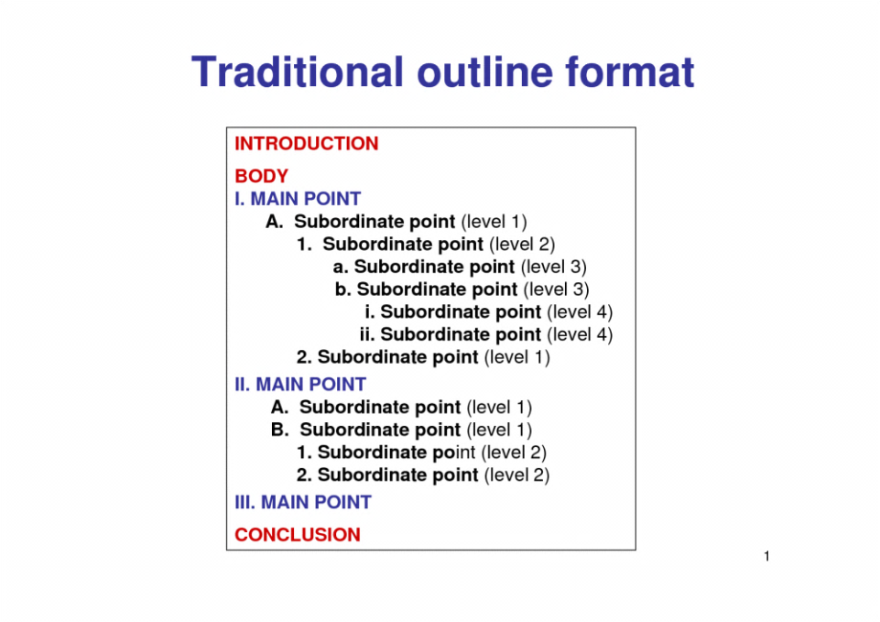 c. No numbers, letters, or Roman numerals are needed.

Example:

***Method:***

Listen and then write in points in an organized pattern based on space indention. Place major points farthest to the left. Indent each more specific point to the right. Levels of importance will be indicated by distance away from the major point. Indentation can be as simple as or as complex as labeling the indentations with Roman numerals or decimals. Markings are not necessary as space relationships will indicate the major/minor points.

***Activity:***

Watch the following video entitled: Misconceptions about Linguistics.

https://www.youtube.com/watch?v=TktPNS1xxTc

Apply the outlining method when you take notes.

**3. The Mapping Method**

Mapping is a form of note taking that uses graphic organizers and diagrams to organize information. It is useful for those who learn best with visuals, and those who like to organize information neatly. Mapping may be difficult to use as a form of note taking during a lecture, but may be an excellent way to reorganize lecture information afterward. However, some students may find it useful in lectures with unanticipated organization.

It creates a great visual that can be later used as a study guide. Students may even utilize this technique when combining notes from both lectures and text book readings. Information may be coded by shape or color so that the source of the information is known. This is very useful when studying and further clarification is needed – individuals will know where to look!

**Activity**: *Read the following text about computers and use a Mind Mapping template when taking notes.*

A computer is an electronic device that manipulates information, or data. It has the ability to store, retrieve, and process data. You may already know that you can use a computer to type documents, send email, play games, and browse the Web. You can also use it to edit or create spreadsheets, presentations, and even videos.

All computers have in common two things: hardware and software.

* + Hardware is any part of your computer that has a physical structure, such as the keyboard or mouse. It also includes all of the computer's internal parts,
  + Software is any set of instructions that tells the hardware what to do and how to do it. Examples of software include web browsers, games, and word processors.

When most people hear the word computer, they think of a personal computer such as a desktop or laptop. Desktop computers are designed to be placed on a desk, and they're typically made up of a few different parts, including the computer case, monitor, keyboard, and mouse. Laptops are battery-powered computers that are more portable than desktops, allowing you to use them almost anywhere. Tablet computers—or tablets—are handheld computers that are even more portable than laptops. Instead of a keyboard and mouse, tablets use a touch-sensitive screen for typing and navigation. The iPad is an example of a tablet.

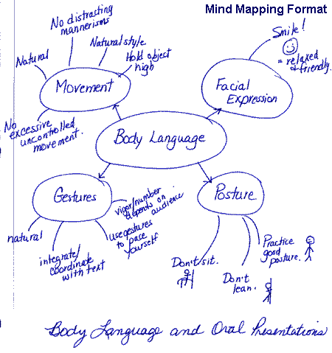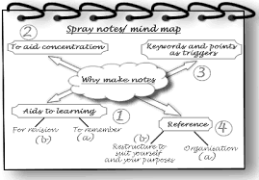

**4. The Charting Method**

If the lecture format is distinct (such as chronological), you may set up your paper by drawing columns and labeling appropriate headings in a table.

Determine the categories to be covered in the lecture. Set up your paper in advance by columns headed by these categories. As you listen to the lecture, record information (words, phrases, main ideas, etc.) into the appropriate category.

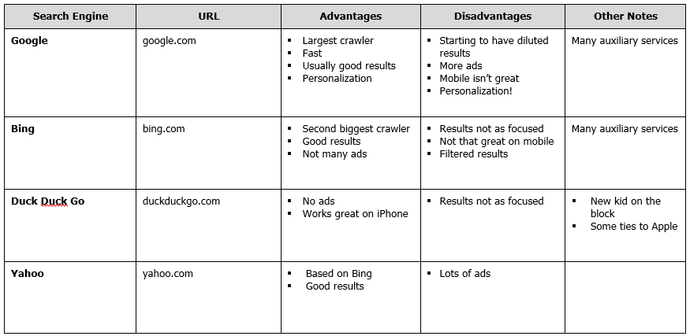

**Activity**: *Read the same text about computers and use a charting template when taking notes.*

**Efficacious study**

**Course 14: Improving Memorization**

1. **Definition:**

***Memory*** is the process by which information is encoded, stored, and retrieved. It is the mental capacity or faculty of retaining and reviving facts, events, impressions, etc., or of recalling or recognizing previous experiences. The loss of memory is described as ***forgetfulness*** or a***mnesia***.

However, ***memorization*** is the process of committing something to memory. It is the mental process undertaken in order to store in memory for later recall items such as experiences, names, appointments, addresses, telephone numbers, lists, stories, poems, pictures, maps, diagrams, facts, music or other visual, auditory, or tactical information.

1. **The 11 properties that determine how difficult something is to memorize.**

* ***Familiarity*** – How much exposure you have had to it
* ***Size*** – How much there is
* ***Order*** – How logically structured it is
* ***Salience*** – How interesting it is
* ***Complexity*** – How difficult it is
* ***Relevance*** – How useful it is to you
* ***Importance*** – How it will impact your life
* ***Immediacy*** – How soon it is required
* ***Abstractness*** – How conceptual it is
* ***Humanness*** – How relatable it is to the human experience
* ***Sensuous*** – How you perceive it with your senses

1. **The ways to improve the effectiveness of your memorization strategy based on each property.**

* ***Familiarity*** – Review it more frequently
* ***Size*** – Break it down into smaller chunks
* ***Order*** – Restructure it in a way that makes more sense to you
* ***Salience*** – Create a whacky or funny story about it
* ***Complexity*** – Break it down into smaller, simpler steps
* ***Relevance*** – Find how it could be useful in your life
* ***Importance*** – Set a goal/objective
* ***Immediacy*** – Set a deadline
* ***Abstractness*** – Relate it to something that exists around you
* ***Humanness*** – Include it in a story with you as the main character
* ***Sensuous*** – Associate it with another sense (smell, taste, touch, etc.)

1. **Strategies**

1. Choose an area with few distractions, don’t listen to music (with lyrics), disconnect, choose optimal memorization time, move around.

2. Record what you memorize.

3. Write everything down.

4. Separate notes into sections.

5. Add new information to what you’ve learned.

6. Write down everything from memory.

7. Teach it to someone (or yourself)

8. Listen to the recordings continuously.

9. Take a break

**Activity 1:** Suppose you need to buy these ten things at the store:

|  |  |
| --- | --- |
| 1) toilet paper 2) tomatoes 3) a loaf of bread 4) apples 5) hamburger buns | 6) a box of corn flakes 7) lettuce 8) ice cream 9) cat food 10) spaghetti |

Think of the various techniques that you can use in order to memorize them.

**Activity 2**: Think of the various techniques that you can use in order to memorize the following poem.

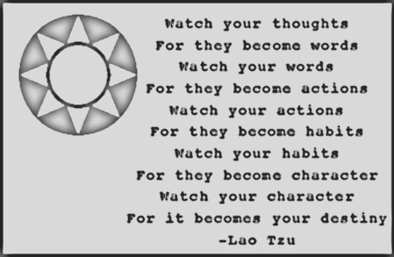

**Course 15: Concentration vs Distraction**

**A/ improving concentration:**

**Definition:**

* Concentration on something involves giving all your attention to it. (COD)
* The [ability](https://dictionary.cambridge.org/dictionary/english/ability) to [think](https://dictionary.cambridge.org/dictionary/english/think) [carefully](https://dictionary.cambridge.org/dictionary/english/carefully) about something you are doing and nothing [else](https://dictionary.cambridge.org/dictionary/english/else). (COD)
* The action or power of focusing all one's attention. (OED)
* If you have great powers of concentration, that means you're able to focus all your attention on the matter at hand. (vocabulary.com)
* Concentration is an attentional process that involves the ability to focus on the task at hand while ignoring distractions. (Aidan Moran, 2012)
* Concentration is defined as the ability to give something our undivided attention to the exclusion of other distractions. (RB, Tignier, 1999)

It is well-known that a great number of Algerian students try to do their best to focus on tasks but very soon find that their minds are wandering. Despite their best intentions, they feel unable to concentrate. Indeed, it is a quite frustrating situation making their performance less effective and successful.

In order to improve their concentration, students have to take into account the following:

1. ***Environment:*** students’ work environment enhances their ability to concentrate. They find it much easier to stay focused when the environment is comfortable and welcoming. Hence, to improve their physical environment, students, for example, have to make their chair ad desk comfortable in order not to be tempted to give up. They can choose landscape pictures and put them up in their work area as well as shut out any kind of distractions. They may also listen to what is commonly known as white noise or relaxing music.
2. ***Adequate nutrition***: students have first to stay hydrated by drinking a lot of water so that their brains operate at high performance. When dehydrated, students will constantly feel tired, become irritable and even sick. They must give too much importance to what they eat because it will be harder for them to concentrate if they rare hungry. So, they have to opt for rich, copious and well-rounded meals. Moreover, walking around is very good and helps increase their focus.
3. ***Mindset:*** research has shown that Attention Deficit Trait or ADT has become so commonplace among university students leading to a low productivity. Hence, they are advised to note down their different worries and set aside time to deal with them, prioritize what to be done, schedule and focus on one task at a time, and limit all kinds of distractions. They must not forget to take frequent short breaks.

**Some useful exercises of concentration**





**Fix gaze on fingers Fix eyes on outstretched glass**

**Sitting still in a chair**

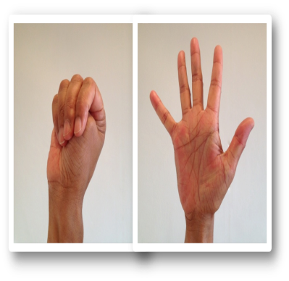

**Concentrating on opening concentrating when reading concentrating on reading**

**And closing fists**



**Eastern way of concentrating practise talking before a glass**

**B/ Overcoming distraction**

**Definition**

Distractions make it difficult to stay focused on your studies. Whether it is working on a project, creating a model, or writing a research paper, distraction affects them all. Every day we are confronted by diversions such as television, Facebook, online shows, cell phones and friends. Sometimes getting easily distracted is the result of insufficient motivation to complete your work. Motivation is your desire to move forward. So what causes distraction? Is it merely being unable to focus? Or could lack of motivation be the cause?

**Types of Distractions**

The internet, your cellphone, your friends, and your home are the source of many distractions just waiting to happen. Facebook, Twitter, YouTube, and e-mail are waiting on the internet. Text messages and phone calls also draw your attention away from your work. Whenever we are distracted, we leave our work; every time we come back to our work, we must refocus and refresh our memory. Therefore, it is important to recognize how your individual distractions affect you in order to eliminate them from your study area.

**Prepare Your Study Area**

Where you study may contribute to distraction. Make sure that your study area is clean and not too comfortable. If it’s too comfortable you may doze off or daydream. Keep your area clean and have the tools and materials you need to begin and finish your work. You do not want to spend time looking for items that you need because you left them at home. When you begin studying, intend to have non-disruptive studying for the designated time set aside – 20 to 50 minutes is most effective. Don’t sabotage yourself – put away your cell phone, iPod (if music distracts you), and close Facebook or else you might get diverted and spend valuable time surfing the web. Bring small snacks and beverages so that when you get hungry you will have something immediately available. Remember: you are trying to develop a habit of studying in an environment where you’re not easily distracted. And consider other study locations – maybe a coffee shop, a spot in the library; whatever works best for you. Become consistent so that studying becomes a natural and productive part of your daily routine.

**Study Buddies and Study Groups**

If you don’t like studying alone, consider a study buddy. Get to know someone in your class. Make sure that your study buddy is not someone you’re extremely friendly with and hang out on the weekend. Remember, your goal is to study; studying with one of your best friends may be unproductive. Studying with a study buddy can also help you stay on track. If you see your study buddy focused on their work, it should help you stay motivated on your work. For many people, starting a regular study group may be helpful. (If you know you will be distracted by a study group, don’t join one!) However, if you learn better through discussion with others, consider this option. At the beginning of the term, form a small group which meets regularly. Again, when considering a study group, be cautious not to simply pick your friends because that may be less productive and add to the list of distractions. Joining a study group or having a study buddy that helps and encourages you, can make studying easier, more enjoyable, and more productive.

**Face the Facts**

Despite your attempts to eliminate them, some distraction is inevitable. Rather than becoming frustrated with little distractions out of your control, learn how to handle them. Often while studying, other things may come to mind. You may be reading or studying and suddenly remember you need to clean your room or the trash needs to be taken out, and pretty soon three hours have passed as you clean up the entire place. Instead of becoming consumed by these distractions, keep a notepad or piece of paper handy and jot down a note to yourself to come back to later. Writing the distraction down helps it leave your mind.

**Course 16: Group vs Individual Work**

**A/ Definitions:**

According to English Oxford Dictionary, a group is a number of people that work together and communicate with one another. They are interdependent whether they are similar or dissimilar, whether they share common beliefs or not. They come together to work on common tasks and for agreed purposes (Benson 2009).

A group work is a student-centered way of teaching and learning based on collaboration and cooperation. Rance-Roney (2010) describes this classroom practice where students work in teams to construct knowledge and accomplish tasks through collaborative interaction. For teachers, when the group work works, they are pleased but when students stare at each other without speaking, teachers feel compelled to do it better.

When students work together, they will increase their confidence, and become responsible for their learning. Through their positive interdependence, they help and encourage each other by sharing ideas and knowledge to attain a common goal.

Individual work, however, help students think things through on their own, at their own level rather than suit group members. These students, who most of the time are introverts, i.e. who tend to concentrate on their own thoughts and feelings rather than communicating with other people, feel more comfortable taking actions on their own and become more creative and focused on what they are doing.

B/ Effectiveness of Group Work

* ***Positive Interdependence***: when students understand that they need each other to tackle the task, they will become more productive. They sink or swim together. Everything they do must be organized and structured and each student has a specific role to play.
* ***Individual accountability***: each member of the group is responsible for achieving the objectives and outcomes of the given activity. The evaluation of the whole group work depends on the efforts made by each member.
* ***Face-to-face interaction***: a group work has to be managed adequately so that students share, encourage each other. Their face-to-face interaction will promote the productivity of each member. Hence, students tend to learn more of what is taught and retain it for a long time.
* ***Collective decisions***: a well-conducted group work relies upon the members’ ability to take the right collective decisions in finding solutions to problems.

**Some disadvantages of group work:**

* The domination of the discussion by one member leading to pressure, and conflict when taking decisions.
* Some members may sit back and let others do all the work. The solution is that each member must get involved in the whole work and be aware of its objectives.
* Any group work takes a longer time than individual work as members are inclined to listen to each other and find a consensus.
* Kicking up a rumpus or making a racket i.e. group members make loud annoying and noisy arguments and protests for a long time.

**C/ Effectiveness of individual work**

* A student can work in their own pace not depending on others. They can decide upon what to do, how and when.
* A student can work faster and concentrate easier.
* Working individually, will help the student get the whole credit for the work they do.

**Some disadvantages of individual work:**

* The work will belayed if the student gets sick and no one will finish it for them.
* A student has to motivate himself/herself. No one will foster them except the teacher in certain occasions.
* A student is responsible for everything to be done. If they fail, it is their fault. No one else to blame for.
* When working alone, student may get bored as there is no one to talk to and share ideas or get help from.

**Course 17: University Research Process (URP)**

***What is research?***

Research is a careful and detailed study into a specific problem, concern or issue using the scientific method. It can be about anything. People do research because they do not know answers. They do research in order to advance research, to challenge or support a theory, or find out better ways of doing things. John W. Creswell (2008) states that "research is a process of steps used to collect and analyze information to increase our understanding of a topic or issue". It consists of three steps: pose a question, collect data to answer the question, and present an answer to the question.

***What is URP?***

The university research process is concerned with the fact of identifying, locating, assessing, and analyzing the information a student needs to support their research question, and then developing and expressing their ideas. These are the same skills they need any time they write a report, proposal, or put together a presentation.

As for library research, it is a step-by-step process that consists of gathering information in order to write a paper, create a presentation, or complete a project. As a student progresses from one step to the next, it is often necessary to rethink, revise, add additional material or even adjust the topic. Much will depend on what is discovered during the research.

A research process becomes more manageable and easier to understand if it broken down into seven steps.

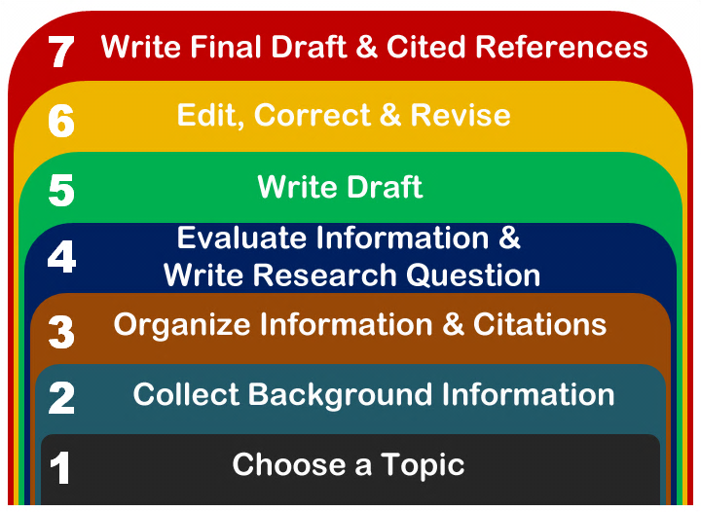

1. ***Choosing a topic***

Identifying and developing a topic is one of the most challenging parts of a research assignment. A topic can be of personal interest to students who will learn more about it. Thus, the research for and writing of a paper will be more enjoyable if they are writing about something that they find original, and interesting (off-the-beaten path). Students have to choose a topic for which they can find a manageable amount of information.

Once a topic is chosen, it can be stated as a question. For example, if you are interested in finding out about violence in in the Algerian football stadiums, you might pose the question "What are the causes of such violence in Algeria?" By posing your subject as a question you can more easily identify the main concepts or keywords to be used in your research.

1. ***Collecting background information***

* **Getting informed**
  1. The communication or reception of knowledge or intelligence.
  2. Knowledge obtained from investigation, study, or instruction.
  3. It is the answer to a question of some kind.
  4. Information is conveyed either as the content of a message or through direct or indirect observation of anything.
  5. Information can be [encoded](https://en.wikipedia.org/wiki/Code) into various forms for [transmission](https://en.wikipedia.org/wiki/Transmission_(telecommunications)) and [interpretation](https://en.wikipedia.org/wiki/Language_interpretation).
  6. Information reduces [uncertainty](https://en.wikipedia.org/wiki/Uncertainty). The more uncertain an event, the more information is required to resolve uncertainty of that event.
  7. The noun ‘information’ is derived from the verb ’informare’’ which means ‘to form an idea of’, ‘to instruct’, ‘to teach’.
  8. Facts provided or learned about something or someone.
  9. We get, obtain, collect, give, provide, share relevant or useful information on, about or regarding…
  10. Information overload: a situation in which you get more information than you can deal with at one time and become tired and confused.
  11. Information theory, information technology, the information superhighway.
  12. An informed choice /decision: based on good knowledge of something.
  13. An informed debate: involving people who have a lot of knowledge.
  14. The concepts of: paperless office, informatization, information society (17 may), digital divide.
* **Types of information sources**

|  |  |  |  |
| --- | --- | --- | --- |
| **Type** | **Information** | **Use** | **Example** |
| Magazine | A magazine is a collection of articles and images about diverse topics of popular interest and current events. Usually these articles are written by journalists or scholars and are geared toward the average adult. Magazines may cover very "serious" material, but to find consistent scholarly information, you should use journals. | * to find information or opinions about popular culture * to find up-to-date information about current events * to find general articles for people who are not necessarily specialists about the topic | * *National Geographic* * *Ebony* * *Sports Illustrated* * *People* |
| Journal | A journal is a collection of articles usually written by scholars in an academic or professional field. An editorial board reviews articles to decide whether they should be accepted. Articles in journals can cover very specific topics or narrow fields of research. | * when doing scholarly research * to find out what has been studied on your topic * to find bibliographies that point to other relevant research | * Journal of Communication * The Historian * Journal of the American Medical Association * Lancet |
| Database | A database contains citations of articles in magazines, journals, and newspapers. They may also contain citations to podcasts, blogs, videos, and other media types. Some databases contain abstracts or brief summaries of the articles, while other databases contain complete, full-text articles. | when you want to find articles on your topic in magazines, journals or newspapers | • Academic Search Complete (a general database)  • Compendex (an engineering database)  • ABI/Inform (a business database) |
| Newspaper | A newspaper is a collection of articles about current events usually published daily. Since there is at least one in every city, it is a great source for local information. | * to find current information about international, national and local events * to find editorials, commentaries, expert or popular opinions | *New York Times* |
| Library catalog | A library catalog is an organized and searchable collection of records of every item in a library and can be found on the library home page. The catalog will point you to the location of a particular source, or group of sources, that the library owns on your topic. | * to find out what items the library owns on your topic * to find where a specific item is located in the library | Virginia Tech's library catalog is called Addison. |
| Book | Books cover virtually any topic, fact or fiction. For research purposes, you will probably be looking for books that synthesize all the information on one topic to support a particular argument or thesis.  Libraries organize and store their book collections on shelves called "stacks." | * when looking for **lots** of information on a topic * to put your topic in context with other important issues * to find historical information * to find summaries of research to support an argument | * Nash, Gary B. ed. *The American People: Creating a Nation and a Society,* 1990. * Silverstone, Roger, ed. *Visions of Suburbia,* 1997. * Smith, J. T. *Roman Villas: A Study in Social Structure,* 1997 |
| Encyclopedia | Encyclopedias are collections of short, factual entries often written by different contributors who are knowledgeable about the topic.  There are two types of encyclopedias: general and subject. General encyclopedias provide concise overviews on a wide variety of topics. Subject encyclopedias contain in-depth entries focusing on one field of study. | * when looking for background information on a topic * when trying to find key ideas, important dates or concepts | • *African-American Encyclopedia* (subject encyclopedia)  • *Encyclopedia Americana* (general encyclopedia)  • *World Book* (general encyclopedi found online) |
| Web site | The Web allows you to access most types of information on the Internet through a browser. One of the main features of the Web is the ability to quickly link to other related information. The Web contains information beyond plain text, including sounds, images, and video. The important thing to do when using information on the Internet is to know how to evaluate it. | • to find current information  • to find both expert and popular opinions  • to find information about hobbies and personal interests | wikipedia.org (a wiki) |

* **Evaluating Sources**

When you encounter *any* kind of source, consider:

1. [**Authority**](https://guides.lib.berkeley.edu/evaluating-resources#authority) - Who is the author? What is their point of view?
2. [**Purpose**](https://guides.lib.berkeley.edu/evaluating-resources#purpose) - Why was the source created? Who is the intended audience?
3. [**Publication & format**](https://guides.lib.berkeley.edu/evaluating-resources#format) - Where was it published? In what medium?
4. [**Relevance**](https://guides.lib.berkeley.edu/evaluating-resources#relevance) - How is it relevant to your research? What is its scope?
5. [**Date of publication**](https://guides.lib.berkeley.edu/evaluating-resources#date) - When was it written? Has it been updated?
6. [**Documentation**](https://guides.lib.berkeley.edu/evaluating-resources#documentation) - Did they cite their sources? Who did they cite?

## Scholarly and Popular Sources

|  |  |  |
| --- | --- | --- |
| **Source** | **Scholarly** | **Popular** |
| **Authors:** | Experts such as scientists, faculty, and historians | Generalists, including bloggers, staff writers, and journalists; not always attributed |
| **Examples:** | [*Journal of Asian History*](https://www.jstor.org/journal/jasiahist), [*Educational Psychologist*](http://www.tandfonline.com/loi/hedp20#.V6Iql5MrJE4)*;*books from University presses such as [Oxford University Press](http://oskicat.berkeley.edu/search~S1/?searchtype=X&searcharg=%22Oxford+University+Press%22) and the [University of California Press](http://oskicat.berkeley.edu/search~S1/?searchtype=X&searcharg=%22university+of+california+press%22) | Wikipedia, CNN.com, About.com; People Magazine, USA Today; bestselling books; books from popular publishers like Penguin and Random House |
| **Focus:** | Specific and in-depth | Broad overviews |
| **Language:** | Dense; includes academic jargon | Easier to read; defines specialized terms |
| **Format:** | Almost always include: abstracts, literature reviews, methodologies, results, and conclusions | Varies |
| **Citations:** | Include bibliographies, citations, and footnotes that follow a particular academic style guide | No formal citations included; may or may not informally attribute sources in text |
| **Before publication:** | Evaluated by peers (other scholars) | Edited by in-house editors or not edited at all |
| **Audience:** | Specialists in the subject area: students, professors and the author's peers | General readers; shouldn't require any special background |
| **Design:** | Mostly text, with some tables and charts; very little photography; no advertising | Glossy images, attractive design; photo illustrations and advertising are more common |

* **Citation**

Research is concerned with reading, taking notes, digesting ideas, and finally presenting a finished product (orally and in written form) that will comprise some ideas of your own and some drawn from other people’s work. It is important to mention that you have to acknowledge both words and ideas that you have gotten from other people.

***What is citation?***

"Ethics, copyright laws, and courtesy to readers require authors to identify the sources of direct quotations and of any facts or opinions not generally known or easily checked"

"Think of documenting your sources as providing a trail for your reader to follow to see the research you performed and discover what led you to your original contribution"

According to the website: [www.plagiarism.org](http://www.plagiarism.org), a citation is the way you tell your readers that certain material in your work came from another source. It also gives your readers the information necessary to find that source again, including:

* information about the author
* the title of the work
* the name and location of the company that published your copy of the source
* the date your copy was published
* the page numbers of the material you are borrowing.

***What is plagiarism?***

Plagiarism is the act of taking the words, ideas, data, illustrations, or statements of another person or source, and presenting them as one's own. Each student is responsible for learning and using proper methods of paraphrasing and footnoting, quotation, and other forms of citation, to ensure that the original author, speaker, illustrator, or source of the material used is clearly acknowledged.

* **Many students are accused of plagiarism because they simply don't understand it and, therefore, don't know how to avoid it.**

***Why Cite?***

Giving credit to the original author by citing sources is the only way to use other people's work without plagiarizing. But there are a number of other reasons to cite sources:

* Citations are extremely helpful to anyone who wants to find out more about your ideas and where they came from.
* Not all sources are good or right -- your own ideas may often be more accurate or interesting than those of your sources. Proper citation will keep you from taking the rap for someone else's bad ideas.
* Citing sources shows the amount of research you've done.

Citing sources strengthens your work by lending outside support to your ideas.

***When to Cite?***

Whenever you borrow words or ideas, you need to acknowledge their source. The following situations almost always require citation:

* whenever you use quotes
* whenever you paraphrase
* whenever you use an idea that someone else has already expressed
* whenever you make specific reference to the work of another
* whenever someone else's work has been critical in developing your own ideas.

***Doesn't citing make my work seem less original?***

Not at all. On the contrary, citing sources actually helps your reader distinguish your ideas from those of your sources. This will actually emphasize the originality of your own work.

## *You Do Not Need to Cite When*

**According to the** [**Purdue OWL**](http://owl.english.purdue.edu/owl/)**, you do** not **need to cite for purposes of credit when:**

* You are writing about your own lived experiences, your own observations and insights, your own thoughts, and your own conclusions about a subject.
* You are writing up your own results obtained through lab or field experiments.
* You use your own artwork, digital photographs, video, audio, etc.
* You are using "common knowledge," things like folklore, common sense observations, myths, urban legends, and historical events (but **not** historical documents).
* You are using generally-accepted facts, e.g., pollution is bad for the environment, including facts that are accepted within particular discourse communities, e.g., in the field of composition studies, "writing is a process" is a generally-accepted fact.

You find the same information not documented in five or more authoritative sources.

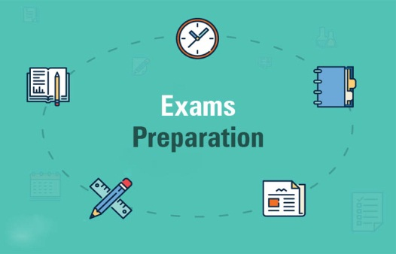**Course 18: Effective exam preparation**

**Introduction**

Preparing for exams is a task most students dread. It involves time and hard work and is the cause of a lot of stress and anxiety. Learning some strategies to make your preparation and revision a little more effective can be the first step towards greater exam success.

Anxiety is usually about fear of the unknown. When it comes to exam preparation there is a lot you can manage to alleviate this feeling!

1. **Managing Time**

Putting off revision will only make the task increasingly more difficult when you do eventually confront it. The key to accepting and dealing with these realities is time management.

* + Use a blank weekly planner to organize the study period available to you. Know how much your exam is worth in the marking process and allot the appropriate amount of study time to it.
  + Set realistic limits on the amount of study you can do and allow regular breaks for rest and relaxation.
  + Alternate harder tasks with easier ones and combine different study activities in each session –this will prevent you from wearing yourself out too quickly and getting bored.
  + Try not to review for more than a couple of hours immediately before the exam –all night cramming sessions are seldom beneficial.

**ii. Managing Space**

* + Find a study space that works for you. A regular spot will help cue your mind for study activity. Keep a routine environment as much as possible, free from distractions (answering email, telephone etc.) and other activities.
  + Keep your study environment for study! Where possible, don’t eat/sleep/relax where you study. Get up to do these things elsewhere.

**iii. Managing Motivation**

* + Remind yourself of why you are at university and what you hope to achieve through your degree. Picture yourself finishing the degree and looking back on this exam period with satisfaction!
  + Use your exam anxiety as a built -in motivator. A certain amount of anxiety can be helpful!
  + Look for the interesting parts of your study to generate an inherent fascination. The exam period is a valuable opportunity to rediscover why you are studying your chosen field.

**iv. Managing the Unknown**

Find out as much information about the structure of your upcoming exams as possible. There should be no surprises in this area! This will involve asking your lecturers and/or tutors questions like the following.

* + Where and when will the exam be held?
  + How much time will be available to complete the exam?
  + How many questions will there be?
  + Will there be a choice of questions?
  + What style will the questions be? For example; multiple-choice, problem-solving,
  + essays, short answer, etc.
  + What percentage of the total marks for the unit is the exam worth?
  + What can we bring with us to the exam?
  + Where can I get copies of past exam papers for this unit?

**v. Managing Revision**

It is important to keep in mind at all times that exams are a test of recall, not recognition. All revision and exam preparation should be directed towards practicing and testing recall. Many students make the mistake of simply reading through their

notes again and again until they feel they ‘know’ it all. However, what they are really learning is to recognize the material. Learning to recall the information requires a much more active approach.

* + Use note-taking methods.
  + Re-read the material, concentrating on the main points and central ideas.
  + Cover your notes and recite everything you can remember – this is the test of your ability to recall the material.
  + Look at your notes again and check your recall. Focus on understanding and learning those areas that you did not remember.
  + Cover your notes again and jot down or recite what you now remember.
  + Continue this process until you have mastered the section of material you are working on.

**Conclusion**

This lecture handout aims at highlighting the notion of the Algerian normal well-adjusted citizen and the role of higher education in shaping and producing such model. Each element included in the syllabus of techniques of university work will certainly enhance students’ to revalue the 4 Rs: respect, responsibility, relationship and rigour that are necessary to facilitate their successful transition into adulthood. Henceforth, future normal adults will effectively be able to manage their time after getting a job, manage their relations with others as fully responsible and good citizens. In all, Algerian universities have to take up the challenge and provide necessary preparations and arrangements in order to change students into good people living in a good society. It is not at all an idealistic or utopic adventure. It only requires well-defined and reliable goals as well as commitment, and determination from the part of university staff and students.

**References**

Benson, J. (2009). Working More Creatively with Groups. 3e. London: Routledge.

Bernstein, D. *(2010). Essentials of Psychology (5th ed.). Cengage Learning.*

Bouma, G. D. & Carland, S. (2016). *The research process*. OUP.

Britton, B. K & Tesser, A. (1991). Effects of time-management practices on college grades.

Journal of educational Psychology, 83 (3), 405-410.

Calkins, L. (2001). The art of teaching reading. New York: Longman.

Dixon, J. (1988). *How to be a successful student, without quitting the human race*. Penguin

Books. Australia.

Dumon, T. Q. (2013).*The power of concentration*. TEP.

Hedge, T. (2000). *Teaching and learning in the language classroom.* OUP.

Hoover, J. (2007). *Best practices: time management*. HarperCollins Publishers Ltd.

Kumar, R. (2014). *Research methodology: a step-by-step guide for beginners.* SAGE

Lamia, M. (1992). *What motivates getting things done procrastination, emotions, and*

*success.* Rowman & Littlefeld.

Lonsdale, M. (2003). *Impact of school libraries on student achievement: a review of the*

*research*. ACER

Mann, D. (2016). *17 anti-procrastination hacks: how to stop being lazy, overcome*

*procrastination, and finally get stuff done*. Kindle Edition.

McWhorter, K & Sember, B,. M. (2014). *Academic Reading*. Pearson Education.

Oliver, P. (2010). *Understanding the research process*. SAGE Study Skills.

Pauk, W.(1974)*. How to Study in College, 2nd edition.* Boston: Houghton Mifflin Co.

Rance-Roney, J.A. (2010). Reconceptualizing interactional groups: Grouping schemes for

maximizing language learning. English Teaching Forum, 48 (1), 20-26.

Walsh, R. (2008). *Time management: proven techniques for making every minute count.*

Adams Business Publications.